**MINOR PROJECT ON**

1. **CRIME REPORT HUB : ONLINE FIR FILING AND CASE MANAGEMENT SYSTEM**

**Minor Project Submitted in Partial Fulfillment of the Requirements for the degree of**

**Bachelor of Computer Application**

**Prepared By**

|  |  |
| --- | --- |
| **NAME** | **ROLL NUMBER** |
| **Salvik Bhowal** | 30901221004 |
| **Suvradip Barua** | 30901221110 |
| **Anindita chakraborty** | 30901221033 |

# Under the Guidance of Arindam Biswas



## TECHNO INDIA SALT LAKE

**EM 4/1, Sector V Kolkata-700091 2020-2023**

Techno Main Salt Lake

Maulana Abdul Kalam Azad University of Technology (MAKAUT) Faculty of MCA & BCA department

**Certificate of Recommendation**

This is to certify that SALVIK BHOWAL, SUVRADIP BARUA, ANINDITA CHAKRABORTY has completed his/her project work titled “Minor project on: E-CRIME REPORT HUB: ONLINE FIR FILING AND CASE MANAGEMENT SYSTEM ”, under the direct supervision and guidance of SIR ARINDAM BISWAS. We are satisfied with his/her/their work, which is being presented for the partial fulfillment of the degree of Bachelor of Computer Application (BCA), West Bengal University of Technology (WBUT), Kolkata– 700032.

Date:-

ARINDAM BISWAS

Teacher in charge of project

DR. SHILADITYA CHOWDHURY

HOD BCA Department TECHNO INDIA SALTLAKE

**Maulana Abul Kalam Azad University of Technology Formerly WBUT**

FACULTY OF MCA DEPARTMENT

Certificate of Approval

The foregoing Minor project is hereby approved as a creditable study of Bachelor of Computer Application (BCA) and presented in a manner satisfactory to warrant its acceptance as a prerequisite to the degree for which it has been submitted. It is understood that by this approval the undersigned do not necessarily endorse or any statement made, opinion expressed or conclusion therein but approve this Minor project only for the purpose for which it is submitted.

Signature of the

Examiners

Final Examination for Evaluation of the Project

Only in case the Minor project is approved.

**ABSTRACT**

The E-CRIME REPORT HUB represents a technological advancement aimed at revolutionizing the conventional method of filing First Information Reports (FIRs) and managing crime-related incidents. This project endeavors to bridge the gap between victims of crimes and law enforcement agencies by introducing an intuitive and accessible online platform that facilitates seamless FIR filing and efficient case management.

At its core, the E-CRIME REPORT HUB is designed to alleviate the constraints associated with the traditional manual filing process. Leveraging Java EE technologies, including JavaServer Pages (JSP), Servlets, and JavaScript for client-side validation, the platform offers users a user-friendly interface for registration, FIR filing, and access to comprehensive crime-related information.

The platform's functionality is rooted in its ability to cater to the diverse needs of users. Victims, irrespective of geographical limitations, can register accounts, file FIRs, and seek guidance through informative articles categorized according to various crime types. User registration entails comprehensive validations utilizing JavaScript, ensuring the accuracy and completeness of the entered data.

Central to the platform's architecture is the utilization of MySQL for robust data management, storing user details and FIR records securely. Each filed FIR undergoes meticulous validation against predefined criteria, ensuring the authenticity and completeness of the report.

The project’s testing phase involved rigorous manual testing methodologies encompassing positive and negative scenarios. Positive testing verified the system's response to valid inputs, ensuring successful registration and FIR filing, while negative testing focused on error handling and the system’s behavior when encountering invalid inputs or incomplete data.

Future enhancements of the E-CRIME REPORT HUB might include the integration of automated testing methodologies, thereby augmenting the efficiency of the testing process and expanding test coverage. Additionally, potential improvements could involve enhancing user interfaces, refining data validation algorithms, and introducing multi-factor authentication for heightened security.

In conclusion, the E-CRIME REPORT HUB stands as a testament to innovation in the realm of law enforcement technology. Through seamless user interactions, robust data management, and comprehensive validations, this platform endeavors to empower victims and law enforcement agencies in addressing and managing crimes effectively in a digitally connected world.

**PREFACE**

In a world interconnected by technology, the paradigm of crime reporting and management necessitates a modern, accessible, and efficient approach. The **E-CRIME REPORT HUB** project emerges as a response to this imperative, seeking to revolutionize the age-old process of filing First Information Reports (FIRs) by introducing an online platform poised to empower victims and streamline law enforcement efforts.

The genesis of this initiative stemmed from a collective recognition of the limitations inherent in traditional crime reporting systems. The aspiration to transcend these limitations birthed a project rooted in innovation, harnessing Java EE technologies, JavaScript validations, and MySQL databases to create an intuitive platform for victims to report crimes and seek aid, transcending geographical barriers.

The journey embarked upon in the creation of the E-CRIME REPORT HUB has been one of technological innovation and user-centric design. Through meticulous planning and development, this project aspires to render the process of FIR filing seamless, secure, and accessible to victims worldwide, amplifying the voices of those affected by crimes.

# ACKNOWLEDGEMENT

It gives us a great sense of pleasure to present the report of the BCA Project undertaken during the BCA Final Year. We take this opportunity to express our sincere gratitude to all those who helped us in various capacities in undertaking this project and devising the report. We are privileged to express our sense of gratitude to our respected teacher Mr. Arindam Biswas whose unparalleled knowledge, moral fiber and judgment along with his know-how was an immense support in completing the project. We are also grateful to Dr. Shiladitya Chowdhury the Head of our Department, Bachelor of Computer Application for the brainwave and encouragement given. We take this opportunity also to thank our friends and contemporaries for their co-operations and compliance.

SALVIK BHOWAL

SUVRADIP BARUA

ANINDITA CHAKRABORTY

CONTENTS

|  |  |  |
| --- | --- | --- |
| **SL NO.** | **TOPIC** | **PAGE NO.** |
| **1.** | INTRODUCTION   * 1. Purpose   2. Scope   3. Technologies to be used | 8 |
| **2.** | CONCEPT AND PROBLEM ANALYSIS | 9 |
| **3.** | FUNCTIONAL OVERVIEW | 10 |
| **4.** | SOFTWARE REQUIREMENTS SPECIFICATIONS   * 1. Introduction   2. Purpose   3. External Interface Requirements   4. Functional Requirements   5. Security Requirements | 11 |
| **5.** | COCOMO | 14 |
| **6.** | DESIGN   * 1. Data Design      1. ERD      2. DFD   2. Database | 16 |
| **7.** | SCREEN DESIGN AND CODE | 21 |
| **8.** | TESTING | 97 |
| **9.** | FUTURE SCOPE | 103 |
| **10.** | CONCLUSION | 104 |
| **11.** | BIBLIOGRAPHY | 104 |

# INTRODUCTION

* 1. **Purpose**

The E-CRIME REPORT HUB is an online FIR filing and case management system that aims to streamline the process of reporting crimes and improve accessibility for victims. The system aims to facilitate efficient management and resolution of these reports by law enforcement agencies. This documentation provides an in-depth understanding of the project's features, technology stack, system architecture, and usage guidelines.

It maintains two levels of users-

1. Admin Level
2. User level

The Application includes: -

User registration and authentication.

File FIR and view past complaints.

Blogs for various categories of crime.

User Interaction.

Admin Panel.

Case Management

# Scope

# The system provides a comprehensive solution allowing users to register accounts, submit detailed FIRs, and track the status of their complaints. Additionally, it supports the submission of quick FIRs for non-registered users. Law enforcement personnel can access the system to manage and update the status of FIRs, fostering a collaborative approach to crime reporting and resolution.

# Technologies to be used

# The project will leverage modern technologies to achieve its objectives:

* IDE : Eclipse IDE
* Programming Language: Java
* Database Management System : MySQL
* Web Development: HTML,CSS, JavaScript
* Libraries & Packages:
  + - mysql-connector-java-8.0.11.jar
    - tomcat-servlet-api-10.0.10.jar
    - Jstl-1.2.jar

# CONCEPT AND PROBLEM ANALYSIS

The "e-crime report hub: online FIR filing and Management System" emerges from a critical examination of the existing processes involved in filing First Information Reports (FIRs) and the inherent challenges faced by both victims and law enforcement agencies. Traditionally, filing an FIR has been a cumbersome and time-consuming process, often requiring individuals to physically visit police stations and navigate bureaucratic hurdles.

**Conceptual Framework:**

At its core, the system envisions a seamless integration of technology to empower individuals in reporting crimes and enhance the efficiency of law enforcement agencies in managing and resolving these reports. The conceptual framework of the system revolves around two primary avenues for filing an FIR: the Registered User Mode and the Quick FIR Mode.

In the Registered User Mode, individuals are encouraged to create accounts, providing essential details such as their name, email, and alternate contact number. This registration facilitates a personalized and secure user experience, allowing users to log in, file detailed FIRs, and track the status of their complaints over time. By creating a centralized database of registered users, the system fosters transparency and accountability.

The Quick FIR Mode caters to those who may not wish to register or lack the time to do so. In this mode, users can swiftly submit necessary details related to the incident without going through a registration process. While this option sacrifices some features available to registered users, it ensures that the system remains inclusive and accessible to all, aligning with the overarching goal of expeditious crime reporting.

**Problem Analysis:**

The need for an online FIR filing and management system is rooted in the inefficiencies and limitations of traditional crime reporting methods. Physical visits to police stations often deter individuals from promptly reporting incidents, resulting in delayed response times and compromised investigative efforts. Additionally, the lack of a centralized system makes it challenging for both victims and law enforcement agencies to track and manage FIRs effectively.

Quick FIRs, filed without registration, address the need for immediacy in reporting. However, they present a unique challenge concerning the absence of user accounts. Since these users do not provide an email address during the filing process, the database must accommodate this by generating unique FIR id’s for Quick FIR section or implementing a placeholder value for unregistered submissions.

Furthermore, the existing paper-based and manual record-keeping systems contribute to inefficiencies in the management of FIRs. The proposed system seeks to replace these archaic methods with a digitized approach, ensuring that information is securely stored, easily retrievable, and systematically managed. By doing so, the system aims to bridge the gap between citizens and law enforcement, fostering a collaborative and technology-driven approach to crime resolution.

**Conclusion:**

The "e-crime report hub" addresses a critical need for an efficient, user-centric, and technology-driven approach to crime reporting and management. By combining the advantages of user registration and quick reporting, the system aims to create a comprehensive platform that not only simplifies the reporting process for victims but also enhances the capabilities of law enforcement agencies in handling and resolving FIRs. The problem analysis underscores the urgency and significance of this solution in modernizing and optimizing the crime reporting ecosystem.

# FUNCTIONAL OVERVIEW

# The functional overview of the "e-crime report hub: online FIR filing and Management System" encompasses a holistic view of the system's capabilities, focusing on key functionalities that cater to both registered users and those opting for a quick FIR submission.

# **User Registration and Account Management:**

# One of the central features of the system is the User Registration and Account Management module. This functionality empowers individuals to create accounts by providing essential information such as their name, email address, and alternate contact number. Upon successful registration, users gain access to a personalized profile, allowing them to log in securely for subsequent FIR filings. This functionality ensures a user-friendly experience and provides the foundation for features such as tracking the status of filed FIRs and accessing historical complaint data.

# **FIR Filing for Registered Users:**

# Registered users enjoy a comprehensive FIR filing process. They are guided through a detailed form where they can provide information regarding the incident, including category, incident description, time, and location. The system seamlessly associates the filed FIR with the user's account, creating a centralized and organized repository of crime reports. This ensures that users can conveniently track the progress and status of their complaints over time, fostering transparency and user engagement.

# **Quick FIR Submission:**

# For those seeking immediate reporting without the necessity of registration, the Quick FIR Submission feature streamlines the process. Users can swiftly input essential details related to the incident, including their name, alternate contact number, category, incident description, time, and location. While quick FIR submissions do not benefit from user accounts, this functionality ensures inclusivity and addresses the urgency associated with certain incidents. The system accommodates these submissions, treating them as standalone reports in the database.

# **Admin/Police Interface and Management:**

# The system's functionality extends beyond citizen-centric features to include a dedicated Police Interface and Management module. Law enforcement personnel can securely log in to access a dashboard that provides an overview of all filed FIRs. This interface facilitates efficient management, allowing officers to update the status of FIRs as they progress, mark them as "solved" or "pending," and provide relevant comments,delete records, modify user details, add new admin. The Police Interface ensures that law enforcement can systematically manage and respond to reported incidents.

# In summary, the functional overview underscores the system's commitment to providing a comprehensive and accessible platform for both citizens and law enforcement agencies. By combining user-centric features with efficient management tools, the system aims to redefine and modernize the FIR filing and resolution process, fostering a collaborative approach to crime reporting.

# SOFTWARE REQUIREMENTS SPECIFICATIONS

* 1. **Introduction**

The "e-crime report hub: online FIR filing and Management System" aims to revolutionize the process of filing First Information Reports (FIRs) by providing a dynamic and user-friendly online platform. This Software Requirements Specification (SRS) document outlines the functional and non-functional requirements essential for the development of this system.

# Purpose

The purpose of this SRS document is to serve as a comprehensive guide for developers, outlining the features, characteristics, and constraints of the "e-crime report hub" system. It provides a clear roadmap for the development team, ensuring a shared understanding of the project's scope and objectives.

# External Interface Requirements

## Hardware requirement

The hardware requirements for the "e-crime report hub: online FIR filing and Management System" are designed to ensure optimal performance, reliability, and scalability. The system is intended to be deployed on standard hardware configurations, and the following are the recommended specifications:

* + - * **Server**
        + Processor: Dual-core processor or higher
        + RAM: 4 GB or higher
        + Storage: 50 GB SSD or higher for the database
      * **Database Server**
        + Processor: Quad-core processor or higher
        + RAM: 4 GB or higher
        + Storage: 50 GB SSD or higher for the database
      * **Network**
        + High-speed internet connection to ensure responsiveness and quick data transfer
        + Firewalls and security measures to protect against unauthorized access
      * **Client Devices**
        + Desktops, laptops, tablets, and smartphones with modern web browsers
        + Internet connectivity for accessing the web-based user interface
        + CPU 1.5 GHz Dual core or higher.
        + RAM 4GB or higher
        + Disk 10 GB or higher.
        + Display 1280*768
        + Graphics Accelerators nVidia or ATI with Support of OpenGL 1.5 or higher

These hardware recommendations are intended as a guideline for optimal performance. The actual hardware requirements may vary based on factors such as the number of concurrent users and the scale of the system deployment.

## Software requirement

* + - * IDE: Eclipse
      * OS: Windows XP or later
      * Browser: Google Chrome , Brave, Microsoft Edge, Firefox
      * JDK 1.8 or higher.
        + Tools & Libraries [jstl, MySQL-connector, tomcat-servlet-api]
      * MySQL 8.0 or later
      * Apache Tomcat 8 or later.

These software requirements ensure compatibility, security, and efficiency throughout the system's lifecycle. It is essential to regularly update and patch the software components to address security vulnerabilities and ensure the system's overall stability. Additionally, the system should comply with industry best practices for software development and deployment

# Functional Requirements

## User Registration

* + - * Description: Users can register accounts by providing their name, email, alternate contact number, and other necessary details.
      * Input: User-provided information during registration.
      * Output: User account creation confirmation.

## FIR Filing

* + - * Description: Registered users can file detailed FIRs, providing information such as category, incident description, time, and location. Non-registered users can submit quick FIRs with essential details.
      * Input: User-provided details related to the incident
      * Output: Confirmation of FIR submission

## User Authentication

* + - * Description: A secure login system for registered users to access their accounts and file FIRs
      * Input: User-provided email and password.
      * Output: Successful login or authentication failure
    1. **FIR Status Tracking**
       - Description: Registered users can track the status of their filed FIRs, including updates on whether they are "solved" or "pending.”
       - Input: User opens ‘MY COMPLAINTS’ section.
       - Output: Display of FIR status and relevant details.
    2. **Admin/Police Interface**
       - Description: Law enforcement personnel can log in to a dedicated interface to manage and update the status of FIRs & perform other CRUD operations.
       - Input: Police login credentials.
       - Output: Access to a dashboard displaying an overview of all filed FIRs, with options to perform CRUD operations.

# Security Requirements

# User Authentication

* Description: Secure authentication for registered users.
* Security Measures: Hashed and salted password storage.
* Access Control: Limit access to certain functionalities based on user roles (user, admin).

# Data Encryption

* Description: Encryption of sensitive user information in the database.
* Security Measures: Implementation of SSL/TLS for data transmission.

# Access Control

* Description: Restrict access to certain functionalities based on user roles.
* Security Measures: Role-based access control to ensure authorized access.

.

# **COCOMO**

The Constructive Cost Model (COCOMO) stands as a prominent software cost estimation model, offering a systematic framework for predicting effort, time, and cost requirements in software development projects.

# **COCOMO TYPES:**

COCOMO is categorized into three types, each tailored to address varying project sizes and complexities:

**Basic COCOMO:** Ideal for small to medium-sized projects, Basic COCOMO utilizes a simple estimation formula **E =a*(KDLOC)b** . This type is characterized by its straightforwardness.

**Intermediate COCOMO:** Suited for medium to large projects, Intermediate COCOMO refines the estimation process by introducing additional attributes related to the product, environment, personnel, and project.

**Detailed COCOMO:** Geared towards very large and complex projects, Detailed COCOMO involves a more intricate estimation formula with 17 different cost drivers, capturing a comprehensive range of project characteristics.

**In COCOMO, projects are categorized into three types:**

1. Organic
2. Semidetached
3. Embedded
4. **Organic:** A development project can be treated of the organic type, if the project deals with developing a well-understood application program, the size of the development team is reasonably small, and the team members are experienced in developing similar methods of projects. **Examples of this type of projects are simple business systems, simple inventory management systems, and data processing systems.**
5. **Semidetached:** A development project can be treated with semidetached type if the development consists of a mixture of experienced and inexperienced staff. Team members may have finite experience in related systems but may be unfamiliar with some aspects of the order being developed. **Example of Semidetached system includes developing a new operating system (OS), a Database Management System (DBMS), and complex inventory management system.**
6. **Embedded:** A development project is treated to be of an embedded type, if the software being developed is strongly coupled to complex hardware, or if the stringent regulations on the operational method exist. **For Example:** ATM, Air Traffic control.

The values of constant according to type of program are as follows :

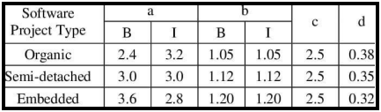

Note: we consider our project as **Organic.** And we follow the **Basic COCOMO** estimation method to calculate effort and development time.

The Basic COCOMO formula is:

**E =a*(KDLOC)b**

Where:

* **E is the effort in person-months**
* **KLOC is the size of the project in KLOC**
* **a and b are constants.**
* **Tdev  is the development time**

**Given that our project size is 5.5KLOC and assuming a = 2.4 and b=1.05. you can calculate the effort E:**

**E = 2.4 x (5.5)1.05**

**E = 2.4 x 5.9893656**

**E = 14.374474 person-months**

**Now, to find the development time you’ll need to know the number of team members (n) , in our case n=3. The development time (Tdev) can be estimated using the formula:**

**Tdev = E/n**

**Tdev  = E/3**

**Tdev = 14.374474 /3**

**Tdev = 4.8 months**

Thus, website requires effort of **14.374474** person per month and the time required for development is **4 months 8 days (Approx)**.

**DESIGN**

* 1. **Data Design**

## Entity Relationship Diagram

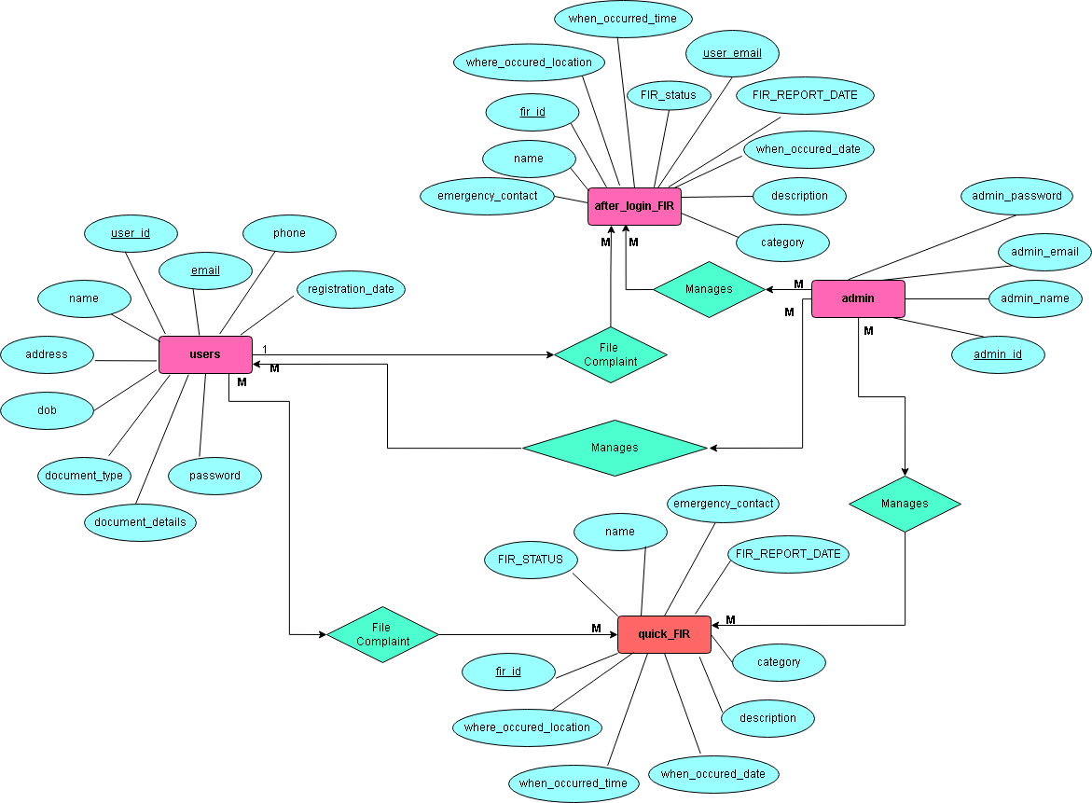

* + 1. **DataFlow Diagram**

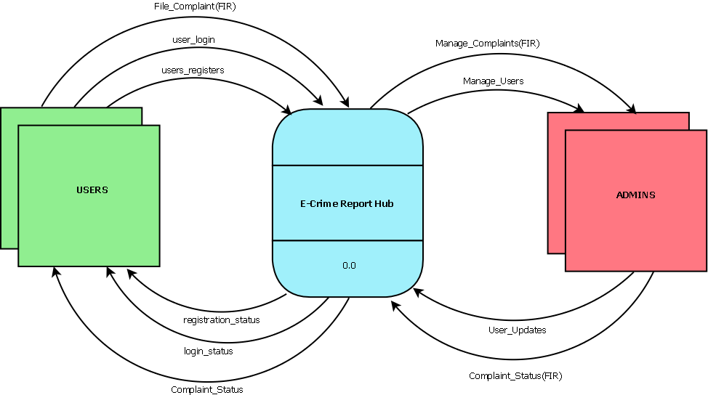

CONTEXT LEVEL DFD | LEVEL 0 DFD

LEVEL 1 DFD

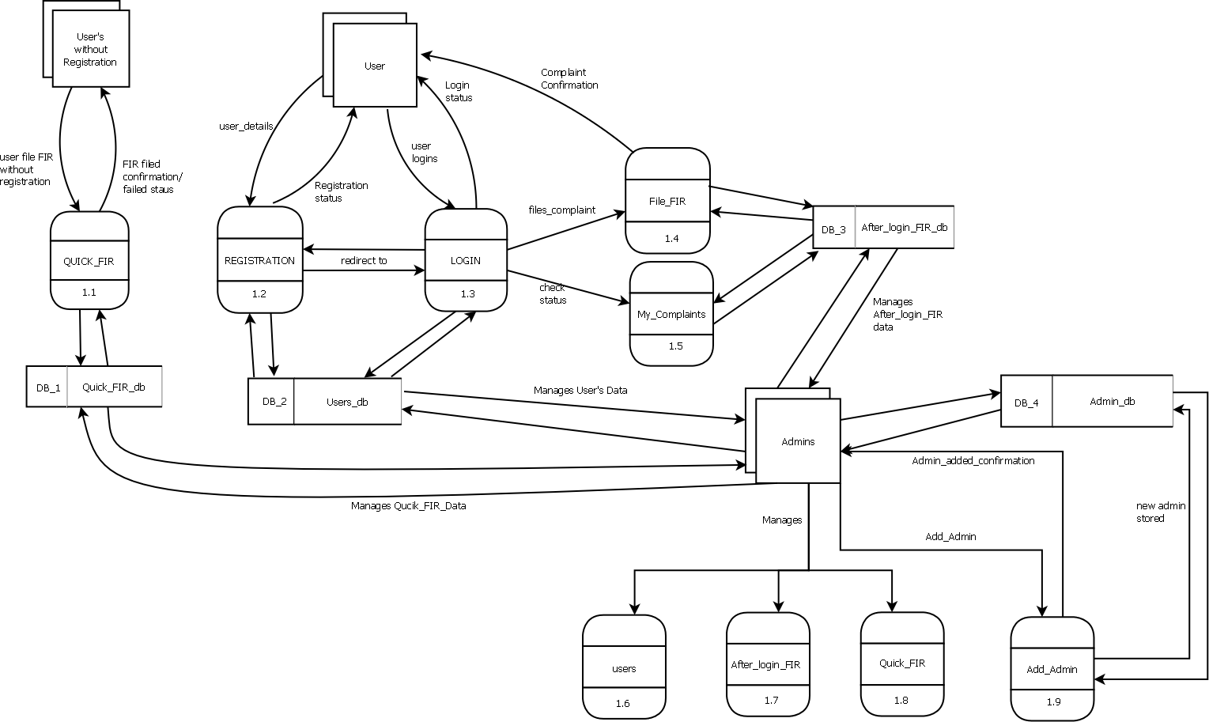

# Database

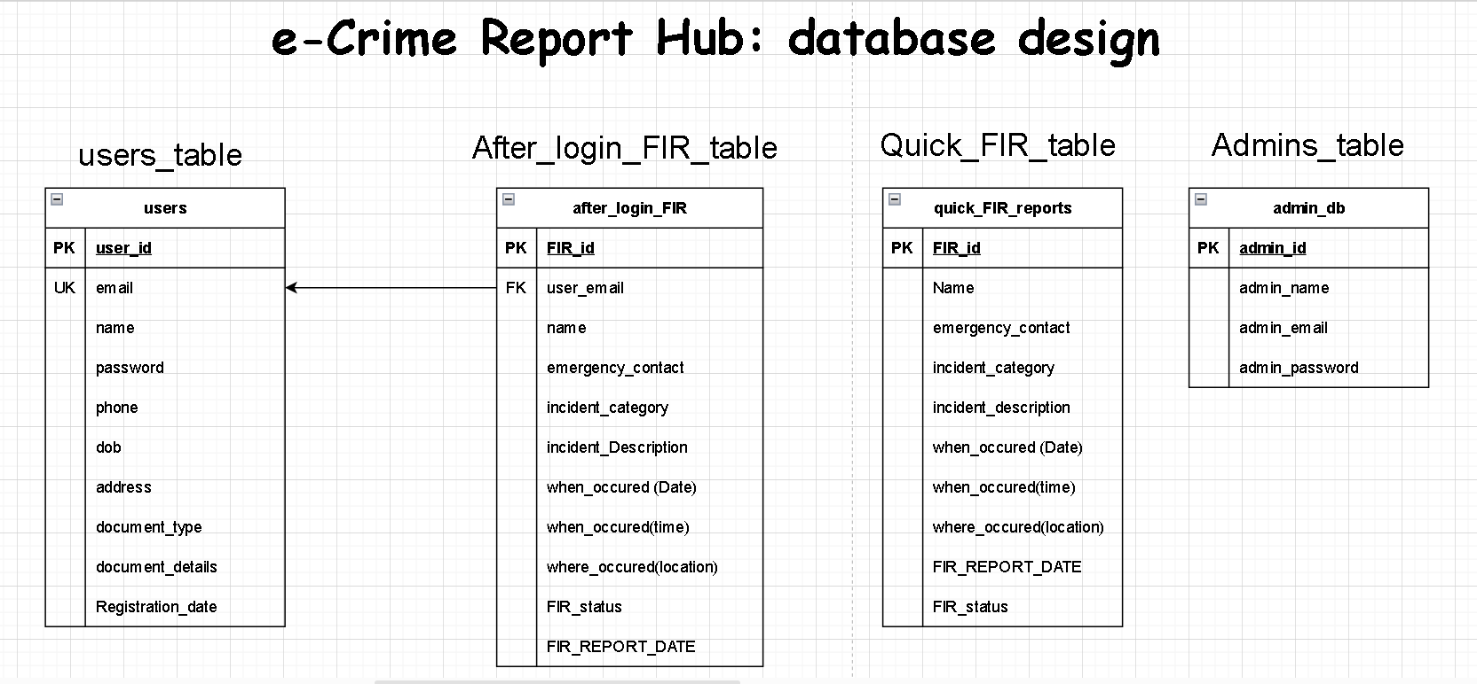

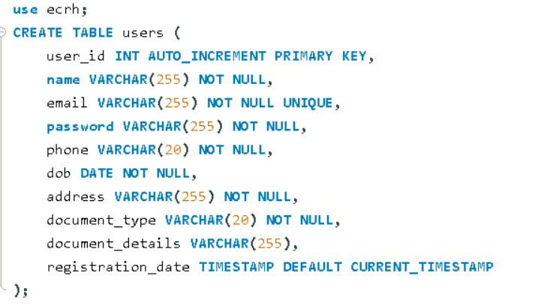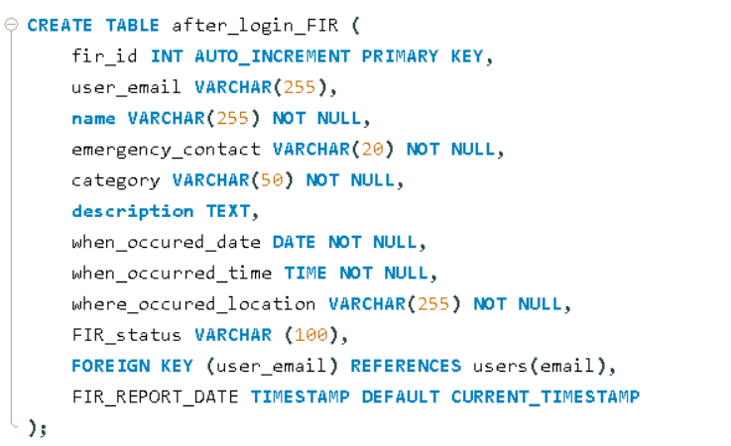

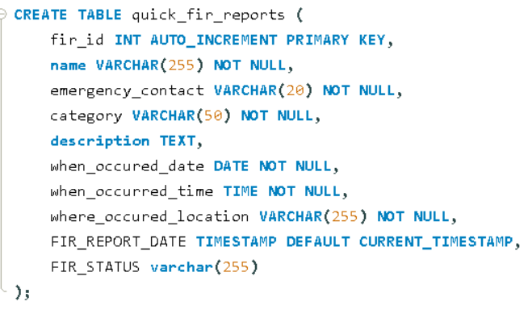

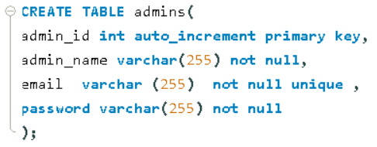  
**TABLE STRUCTURE:-**

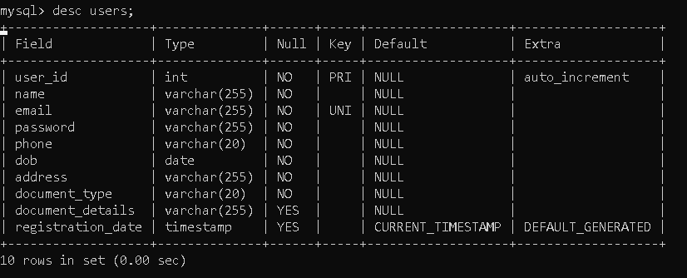

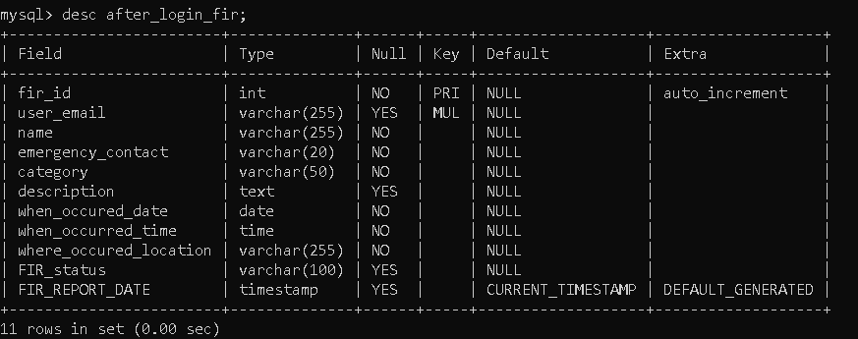

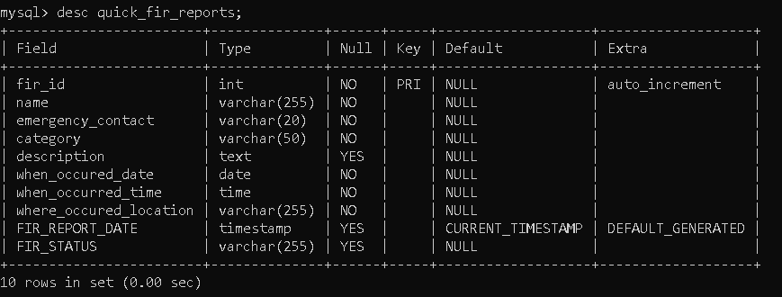

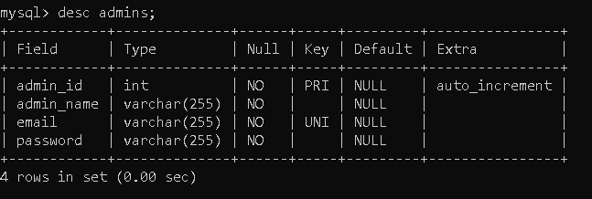

**SAMPLE RECORDS:-**

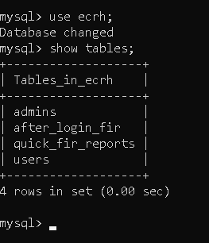

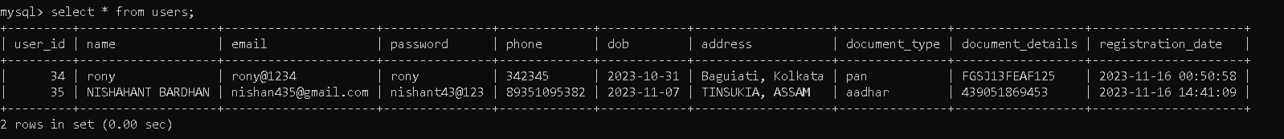



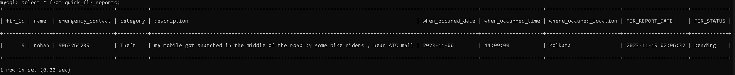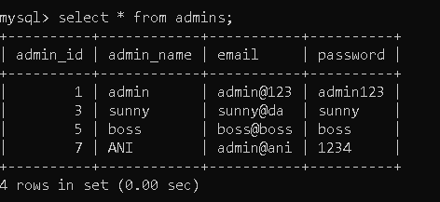

**SCREEN DESIGN AND CODE**

**INDEX PAGE :-**

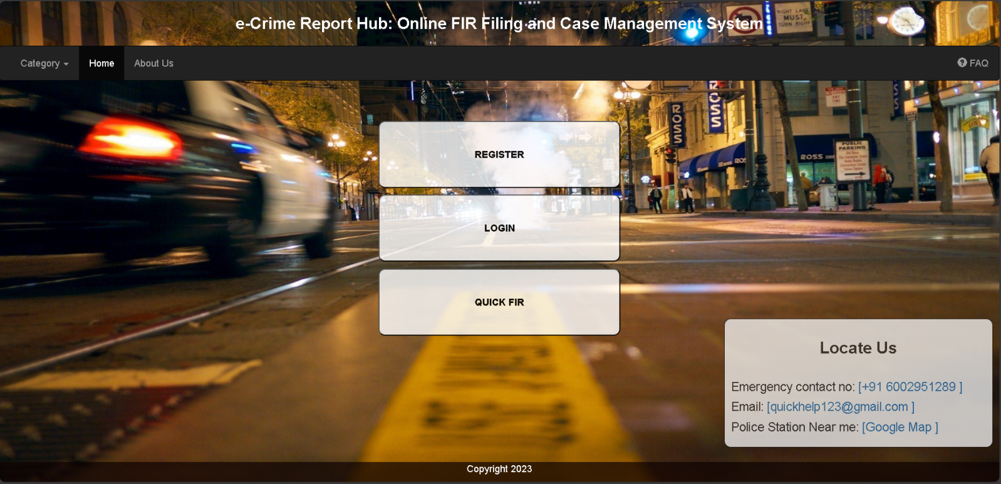

INDEX JSP CODE:-

<%@ page language="java" contentType="text/html; charset=ISO-8859-1" pageEncoding="ISO-8859-1"%>

<%@ page session="false" %>

<!DOCTYPE html>

<html lang="en">

<head>

<title>E-Crime Report Hub</title>

<meta charset="utf-8">

<meta name="viewport" content="width=device-width, initial-scale=1">

<link rel="stylesheet" href="https://maxcdn.bootstrapcdn.com/bootstrap/3.4.1/css/bootstrap.min.css">

<script src="https://ajax.googleapis.com/ajax/libs/jquery/3.6.4/jquery.min.js"></script>

<script src="https://maxcdn.bootstrapcdn.com/bootstrap/3.4.1/js/bootstrap.min.js"></script>

<style>

/* Custom CSS for the body */

.container{

opacity: 0.9 }

body {

font-family: Arial, sans-serif;

margin: 0;

padding: 0;

background-image: url('images/3.jpg');

background-size: cover;

background-repeat: no-repeat;

background-attachment: fixed;

background-position: center center;

/* background-color: rgba(9, 118, 165, 0.1);

Custom CSS for the "Emergency" container */

.emergency {

position: absolute;

bottom: 1px;

right: 10px;

width: 400px;

margin-bottom: 50px;

border: 1px solid #070000;

padding: 10px;

background-color: rgba(249, 249, 249, 1);

/* Adjusted background color with transparency */

border-radius: 10px;

opacity: 0.75}

@media (max-width: 767px) {

/* Media query for screens smaller than 768px (phones) */

.emergency {

position: static;

/* Remove absolute positioning */

margin: 20px auto;

/* Center the container horizontally */

width: 90%;

/* Adjust the width for smaller screens */

}

}

.footer {

position: fixed;

left: 0;

bottom: 0;

width: 100%;

background-color: rgba(13, 2, 2, 0.7);

color: white;

text-align: center;

}

</style>

<h3 style="text-align: center;font-weight:bold; margin-bottom: 20px; color: white;">e-Crime Report Hub: Online FIR Filing and Case

Management System

</h3>

</head>

<body>

<nav class="navbar navbar-inverse">

<div class="container-fluid">

<ul class="nav navbar-nav">

<li class="dropdown"><a class="dropdown-toggle" data-toggle="dropdown" href="#">Category <span

class="caret"></span></a>

<ul class="dropdown-menu">

<li><a href="cat_theft.jsp">Theft</a></li>

<li><a href="cat_assault.jsp">Assault</a></li>

<li><a href="cat_fraud.jsp">Fraud</a></li>

<li><a href="cat_DRC.jsp">Drug-Related Crimes</a></li>

<li><a href="cat_vandalism.jsp">Vandalism</a></li>

</ul>

</li>

<li class="active"><a href="index.jsp">Home</a></li>

<li><a href="about_us.jsp">About Us</a></li>

</ul>

<ul class="nav navbar-nav navbar-right">

<li><a href="FAQ.jsp"><span class="glyphicon glyphicon-question-sign"></span> FAQ</a></li>

</ul>

</div>

</nav>

<div class="container">

<div class="row">

<div class="col-xs-12 col-sm-6 col-sm-offset-3 col-md-4 col-md-offset-4">

<div class="Qfir">

<center> <button id='register'

style="width: 100%;color:black; font-weight:bold; height: 100px; margin-top: 40px; background-color: rgba(255, 255, 255, 0.9); border-radius: 10px;"

onclick="location.href='registration.jsp';">REGISTER</button>

</center>

</div>

<div class="Qfir">

<center> <button id='login'

style="width: 100%; color:black; font-weight:bold; height: 100px; margin-top: 10px; background-color: rgba(255, 255, 255, 0.9); border-radius: 10px;"

onclick="location.href='login.jsp';">LOGIN</button>

</center>

</div>

<div class="Qfir">

<center> <button id='qfir'

style="width: 100%;color:black; font-weight:bold;height: 100px; margin-top: 10px; background-color: rgba(255, 255, 255, 0.9); border-radius: 10px; "

onclick="location.href='quickfir.jsp';">QUICK

FIR</button></center>

</div>

</div>

</div>

</div>

<div class="emergency">

<h3 style="text-align: center;font-weight: bold; margin-bottom: 35px;">Locate Us</h3>

<p>

<h4>Emergency contact no: <a href="#">[+91 6002951289 ]</a></h4>

</p>

<p>

<h4>Email: <a href="#">[quickhelp123@gmail.com ]</a> </h4>

</p>

<p>

<h4>Police Station Near me: <a href="#">[Google Map ]</a> </h4>

</p>

</div>

<div class="footer">

<p>Copyright 2023</p>

</div>

<script>

// Clear any existing session

if (sessionStorage) {

sessionStorage.clear();

}

// Disable the browser's back button

history.pushState(null, null, location.href);

window.onpopstate = function () {

history.go(1);

};

</script>

</body>

</html>

**REGISTRATION PAGE :-**

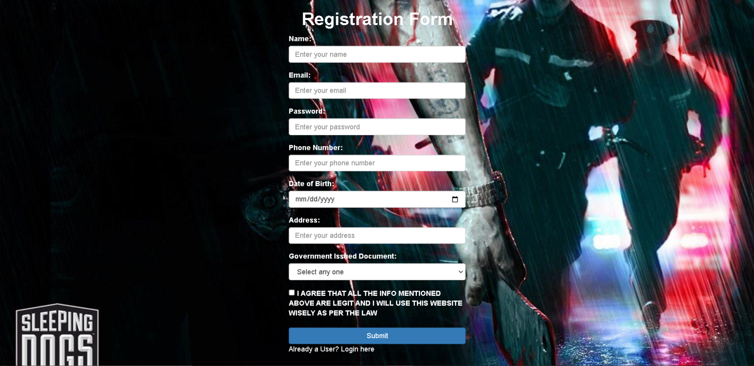

REGISTRATION JSP CODE:

<%@ page language="java" contentType="text/html; charset=ISO-8859-1"

pageEncoding="ISO-8859-1"%>

<!DOCTYPE html>

<html lang="en">

<head>

<title>Registration Form</title>

<meta charset="utf-8">

<meta name="viewport" content="width=device-width, initial-scale=1">

<link rel="stylesheet" href="https://maxcdn.bootstrapcdn.com/bootstrap/3.4.1/css/bootstrap.min.css">

<script src="https://ajax.googleapis.com/ajax/libs/jquery/3.6.4/jquery.min.js"></script>

<script src="https://maxcdn.bootstrapcdn.com/bootstrap/3.4.1/js/bootstrap.min.js"></script>

</head>

<style>

body {

font-family: Arial, sans-serif;

margin: 0;

padding: 0;

background-color: rgba(9, 118, 165, 0.7);

}

body {

font-family: Arial, sans-serif;

margin: 0;

padding: 0;

background-image: url('images/7.jpg');

background-size: cover;

background-repeat: no-repeat;

background-attachment: fixed;

background-position: center center;

background-color: rgba(9, 118, 165, 0.5);

}

label {

color: white;

}

</style>

<body>

<div class="container">

<div class="row">

<div class="col-xs-12 col-sm-6 col-sm-offset-3 col-md-4 col-md-offset-4">

<h1 style="text-align: center; color:white;font-weight: bold;">Registration Form</h2>

<form onsubmit="return validateForm()" method="post" action="RegisterServlet" >

<div class="form-group">

<label for="name">Name:</label>

<input type="text" class="form-control" id="name" name="name" placeholder="Enter your name" required>

</div>

<div class="form-group">

<label for="email">Email:</label>

<input type="email" class="form-control" id="useremail" name="email" placeholder="Enter your email" required>

<span id="emailError" style="color: red;"></span>

</div>

<div class="form-group">

<label for="password">Password:</label>

<input type="password" class="form-control" id="userpassword" name="password" placeholder="Enter your password"

required>

</div>

<div class="form-group">

<label for="phone">Phone Number:</label>

<input type="tel" class="form-control" id="phone" name="phone" placeholder="Enter your phone number"

required>

</div>

<div class="form-group">

<label for="dob">Date of Birth:</label>

<input type="date" class="form-control" id="dob" name="dob" required>

</div>

<div class="form-group">

<label for="address">Address:</label>

<input type="text" class="form-control" id="address" name="address" placeholder="Enter your address" required>

</div>

<div class="form-group">

<label for="document">Government Issued Document:</label>

<select class="form-control" id="document" name="document_type" onchange="showDocumentDetails()" required>

<option value="select">Select any one</option>

<option value="aadhar">Aadhaar Number</option>

<option value="pan">PAN Number</option>

<option value="driving">Driving License Number</option>

<option value="passport">Passport Number</option>

</select>

</div>

<div id="documentDetails" class="form-group" style="display: none;">

<label for="documentDetailsInput">Document Details:</label>

<input type="text" class="form-control" id="documentDetailsInput" name="document_details"

placeholder="Enter document details">

</div>

<div class="form-group">

<label>

<input type="checkbox" id="agreement" required>

I AGREE THAT ALL THE INFO MENTIONED ABOVE ARE LEGIT AND I WILL USE THIS WEBSITE WISELY AS

PER

THE LAW

</label>

</div>

<button type="submit" class="btn btn-primary btn-block" >Submit</button>

<p><a style=color:white; href="login.jsp">Already a User? Login here</a>

</form>

</div>

</div>

</div>

<script>

function validateForm() {

var emailInput = document.getElementById("email");

var emailError = document.getElementById("emailError");

var email = emailInput.value;

if (email.indexOf("@") === -1) {

emailError.textContent = "Please enter a valid email address.";

emailInput.focus();

return false;

}

return true;

}

function showDocumentDetails() {

var documentSelect = document.getElementById("document");

var documentDetails = document.getElementById("documentDetails");

var documentDetailsInput = document.getElementById("documentDetailsInput");

if (documentSelect.value !== "select") {

documentDetails.style.display = "block";

documentDetailsInput.setAttribute("required", "true");

// Set the placeholder based on the selected option

var selectedOption = documentSelect.options[documentSelect.selectedIndex].text;

documentDetailsInput.placeholder = "Enter " + selectedOption + " details";

} else {

documentDetails.style.display = "none";

documentDetailsInput.removeAttribute("required");

}

}

</script>

</body>

</html>

REGISTRATION SERVLET CODE:-

package com.ecrh.backend;

import java.io.IOException;

import java.io.PrintWriter;

import java.sql.Connection;

import java.sql.DriverManager;

import java.sql.PreparedStatement;

import java.sql.Timestamp;

import javax.servlet.RequestDispatcher;

import javax.servlet.ServletException;

import javax.servlet.annotation.WebServlet;

import javax.servlet.http.HttpServlet;

import javax.servlet.http.HttpServletRequest;

import javax.servlet.http.HttpServletResponse;

@WebServlet("/RegisterServlet")

public class Register extends HttpServlet {

private static final long serialVersionUID = 1L;

public Register() {

}

protected void doGet(HttpServletRequest request, HttpServletResponse response)

throws ServletException, IOException {

response.getWriter().append("Served at: ").append(request.getContextPath());

}

protected void doPost(HttpServletRequest request, HttpServletResponse response)

throws ServletException, IOException {

doGet(request, response);

PrintWriter out = response.getWriter();

String myname = request.getParameter("name");

String myemail = request.getParameter("email");

String mypass = request.getParameter("password");

String myphone = request.getParameter("phone");

String mydob = request.getParameter("dob");

String myaddress = request.getParameter("address");

String mydoctype = request.getParameter("document_type");

String mydocdetails = request.getParameter("document_details");

try {

Class.forName("com.mysql.cj.jdbc.Driver");

Connection con = DriverManager.getConnection("jdbc:mysql://localhost:3306/ecrh", "root", "rony");

PreparedStatement ps = con.prepareStatement(

"insert into users (name, email, password, phone, dob, address, document_type, document_details, registration_date) values(?,?,?,?,?,?,?,?,?)",

PreparedStatement.RETURN_GENERATED_KEYS);

ps.setString(1, myname);

ps.setString(2, myemail);

ps.setString(3, mypass);

ps.setString(4, myphone);

ps.setString(5, mydob);

ps.setString(6, myaddress);

ps.setString(7, mydoctype);

ps.setString(8, mydocdetails);

// Set the registration_date to the current timestamp

Timestamp currentTimestamp = new Timestamp(System.currentTimeMillis());

ps.setTimestamp(9, currentTimestamp);

int count = ps.executeUpdate();

if (count > 0) {

// Registration was successful, so retrieve the auto-generated user_id

java.sql.ResultSet generatedKeys = ps.getGeneratedKeys();

if (generatedKeys.next()) {

int generatedId = generatedKeys.getInt(1);

response.setContentType("text/html");

out.print("<h3>User registered successfully with ID: " + generatedId + "</h3>");

}

RequestDispatcher rd = request.getRequestDispatcher("/registration_success.jsp");

rd.forward(request, response);

} else {

// Registration was not successful, do not display user_id

RequestDispatcher rd = request.getRequestDispatcher("/registration_error.jsp");

rd.forward(request, response);

}

} catch (Exception e) {

e.printStackTrace();

response.setContentType("text/html");

out.print("<h3>Exception Occurred: " + e.getMessage() + " </h3>");

RequestDispatcher rd = request.getRequestDispatcher("/registration_error.jsp");

rd.forward(request, response);

}

}

}

**LOGIN PAGE :-**

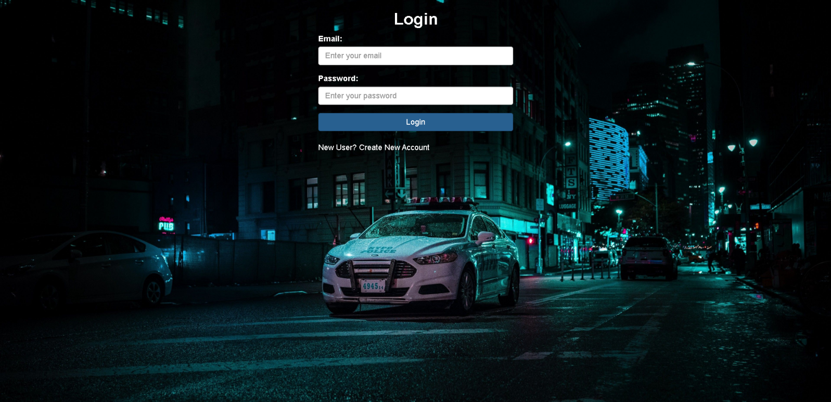

LOGIN JSP CODE

<%@ page language="java" contentType="text/html; charset=ISO-8859-1"

pageEncoding="ISO-8859-1"%>

<!DOCTYPE html>

<html lang="en">

<head>

<title>Login Page</title>

<meta charset="utf-8">

<meta name="viewport" content="width=device-width, initial-scale=1">

<link rel="stylesheet" href="https://maxcdn.bootstrapcdn.com/bootstrap/3.4.1/css/bootstrap.min.css">

<script src="https://ajax.googleapis.com/libs/jquery/3.6.4/jquery.min.js"></script>

<script src="https://maxcdn.bootstrapcdn.com/bootstrap/3.4.1/js/bootstrap.min.js"></script>

</head>

<style>

body {

font-family: Arial, sans-serif;

margin: 0;

padding: 0;

background-size: cover;

background-image: url('images/11.jpg');

background-repeat: no-repeat;

background-attachment: fixed;

background-position: center center;

background-color: rgba(9, 118, 165, 0.7);

}

label {

color: white;

font-weight: bold;

}

</style>

<body>

<div class="container">

<div class="row">

<div class="col-xs-12 col-sm-6 col-sm-offset-3 col-md-4 col-md-offset-4">

<h2 style="text-align: center; color:white ; font-weight: bold;">Login</h2>

<form action="loginServlet" method="post">

<div class="form-group">

<label for="email">Email:</label>

<input type="email" class="form-control" id="email" name="email" placeholder="Enter your email"

required>

</div>

<div class="form-group">

<label for="password">Password:</label>

<input type="password" class="form-control" id="password" name="password"

placeholder="Enter your password" required>

</div>

<button type="submit" class="btn btn-primary btn-block">Login</button>

<br>

<p > <a style=color:white; href="registration.jsp">New User? Create New Account</a>

</form>

<!-- Display error message if it exists -->

<% String errorMessage = (String) request.getAttribute("errorMessage"); %>

<% if (errorMessage != null) { %>

<div class="alert alert-danger" role="alert" style="margin-top: 10px;">

<strong>Error:</strong> <%= errorMessage %>

</div>

<% } %>

</div>

</div>

</div>

</body>

</html>

LOGIN SERVLET CODE:-

package com.ecrh.backend;

import java.io.IOException;

import java.sql.Connection;

import java.sql.DriverManager;

import java.sql.PreparedStatement;

import java.sql.ResultSet;

import javax.servlet.RequestDispatcher;

import javax.servlet.ServletException;

import javax.servlet.annotation.WebServlet;

import javax.servlet.http.HttpServlet;

import javax.servlet.http.HttpServletRequest;

import javax.servlet.http.HttpServletResponse;

import javax.servlet.http.HttpSession;

@WebServlet("/loginServlet")

public class Login extends HttpServlet {

private static final long serialVersionUID = 1L;

public Login() {

super();

}

protected void doPost(HttpServletRequest request, HttpServletResponse response) throws ServletException, IOException {

response.setContentType("text/html");

String myemail = request.getParameter("email");

String mypass = request.getParameter("password");

String errorMessage = null; // Initialize an error message

try {

Class.forName("com.mysql.cj.jdbc.Driver");

Connection con = DriverManager.getConnection("jdbc:mysql://localhost:3306/ecrh", "root", "rony");

PreparedStatement ps = con.prepareStatement("select * from users where email = ? and password = ?");

ps.setString(1, myemail);

ps.setString(2, mypass);

ResultSet rs = ps.executeQuery();

if (rs.next()) {

HttpSession session = request.getSession();

session.setAttribute("session_username", rs.getString("name"));

session.setAttribute("user_email", rs.getString("email")); // Store the user_email in the session

// session.setAttribute("user_role", "user"); // Indicate this is a user session

// Redirect to the after_login page

response.sendRedirect("after_login.jsp");

} else {

// Set an error message

errorMessage = "Email and password do not match.";

}

} catch (Exception e) {

e.printStackTrace();

// Set an error message for exceptions

errorMessage = "An error occurred while processing your request.";

}

// If there is an error message, forward to the login page with the error message

if (errorMessage != null) {

request.setAttribute("errorMessage", errorMessage);

RequestDispatcher rd = request.getRequestDispatcher("/login.jsp");

rd.forward(request, response);

}

}

}

**QUICK FIR PAGE :**-

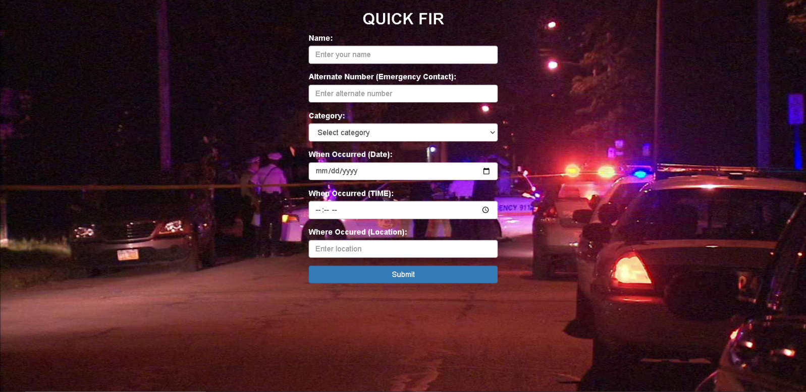

**QUICK FIR JSP CODE:**

<!DOCTYPE html>

<html lang="en">

<head>

<title>QUICK FIR</title>

<meta charset="utf-8">

<meta name="viewport" content="width=device-width, initial-scale=1">

<link rel="stylesheet" href="https://maxcdn.bootstrapcdn.com/bootstrap/3.4.1/css/bootstrap.min.css">

<script src="https://ajax.googleapis.com/ajax/libs/jquery/3.6.4/jquery.min.js"></script>

<script src="https://maxcdn.bootstrapcdn.com/bootstrap/3.4.1/js/bootstrap.min.js"></script>

</head>

<style>

body {

font-family: Arial, sans-serif;

margin: 0;

padding: 0;

background-size: cover;

background-image: url('images/qfir1.jpg');

background-repeat: no-repeat;

background-attachment: fixed;

background-position: center center;

background-color: rgba(9, 118, 165, 0.2);

}

label{

color: white;}

</style>

<body>

<div class="container">

<div class="row">

<div class="col-xs-12 col-sm-6 col-sm-offset-3 col-md-4 col-md-offset-4">

<h2 style="text-align: center;color: white; font-weight:bold;">QUICK FIR</h2>

<form action="quickFIRServlet" method="post">

<div class="form-group">

<label for="name">Name:</label>

<input type="text" class="form-control" id="name" name="name" placeholder="Enter your name"

required>

</div>

<div class="form-group">

<label for="emergencyContact">Alternate Number (Emergency Contact):</label>

<input type="tel" class="form-control" id="emergencyContact" name="emergencyContact"

placeholder="Enter alternate number" required>

</div>

<div class="form-group">

<label for="category">Category:</label>

<select class="form-control" id="category" name="category" required>

<option value="">Select category</option>

<option value="Theft">Theft</option>

<option value="Assault">Assault</option>

<option value="Fraud">Fraud</option>

<option value="Drug-Related Crimes">Drug-Related Crimes</option>

<option value="Vandalism">Vandalism</option>

<option value="Others">Others</option>

</select>

</div>

<div class="form-group" id="incidentDescriptionGroup" style="display: none;">

<label for="description">Incident Description:</label>

<textarea class="form-control" id="description" name="description" rows="4"

placeholder="Enter incident description"></textarea>

</div>

<div class="form-group">

<label for="date">When Occurred (Date):</label>

<input type="date" class="form-control" id="date" name="date" required>

</div>

<div class="form-group">

<label for="whenOccurred">When Occurred (TIME):</label>

<input type="time" class="form-control" id="whenOccurredTime" name="whenOccurredTime" required>

</div>

<div class="form-group">

<label for="location">Where Occured (Location):</label>

<input type="text" class="form-control" id="location" name="location"

placeholder="Enter location" required>

</div>

<button type="submit" class="btn btn-primary btn-block">Submit</button>

</form>

</div>

</div>

</div>

<script>

$(document).ready(function () {

$("#category").change(function () {

var selectedCategory = $(this).val();

var incidentDescriptionGroup = $("#incidentDescriptionGroup");

if (selectedCategory !== "") {

incidentDescriptionGroup.show();

} else {

incidentDescriptionGroup.hide();

}

});

});

</script>

</body>

</html>

**QUICK FIR SERVLET CODE:-**

package com.ecrh.backend;

import java.io.IOException;

import java.sql.Connection;

import java.sql.DriverManager;

import java.sql.PreparedStatement;

//import java.sql.ResultSet;

import java.sql.SQLException;

import java.sql.Timestamp;

import javax.servlet.ServletException;

import javax.servlet.annotation.WebServlet;

import javax.servlet.http.HttpServlet;

import javax.servlet.http.HttpServletRequest;

import javax.servlet.http.HttpServletResponse;

@WebServlet("/quickFIRServlet")

public class QuickFir extends HttpServlet {

private static final long serialVersionUID = 1L;

public QuickFir() {

super();

}

protected void doPost(HttpServletRequest request, HttpServletResponse response)

throws ServletException, IOException {

// Retrieve data from the form

String name = request.getParameter("name");

String emergencyContact = request.getParameter("emergencyContact");

String category = request.getParameter("category");

String description = request.getParameter("description");

String whenOccurredDate = request.getParameter("date");

String whenOccurredTime = request.getParameter("whenOccurredTime");

String whereOccurredLocation = request.getParameter("location");

try {

// Create a database connection

Class.forName("com.mysql.cj.jdbc.Driver");

Connection con = DriverManager.getConnection("jdbc:mysql://localhost:3306/ecrh", "root", "rony");

// Prepare and execute the SQL query to insert FIR data

String query = "INSERT INTO quick_fir_reports ( name, emergency_contact, category, description, when_occured_date, when_occurred_time, where_occured_location,FIR_REPORT_DATE) VALUES (?, ?, ?, ?, ?, ?, ?, ?)";

PreparedStatement ps = con.prepareStatement(query);

// ps.setString(1, fir_id);

ps.setString(1, name);

ps.setString(2, emergencyContact);

ps.setString(3, category);

ps.setString(4, description);

ps.setString(5, whenOccurredDate);

ps.setString(6, whenOccurredTime);

ps.setString(7, whereOccurredLocation);

// Set the registration_date to the current timestamp

Timestamp currentTimestamp = new Timestamp(System.currentTimeMillis());

ps.setTimestamp(8, currentTimestamp);

// Execute the query

int rowsAffected = ps.executeUpdate();

// Close the database connection

con.close();

if (rowsAffected > 0) {

// Data was successfully inserted

response.sendRedirect("QFIR_success.jsp");

} else {

// Insertion failed

response.sendRedirect("QFIR_error.jsp");

}

} catch (ClassNotFoundException | SQLException e) {

e.printStackTrace();

// Handle database and other exceptions

response.sendRedirect("QFIR_error.jsp");

}

}

}

**FAQ PAGE :**-

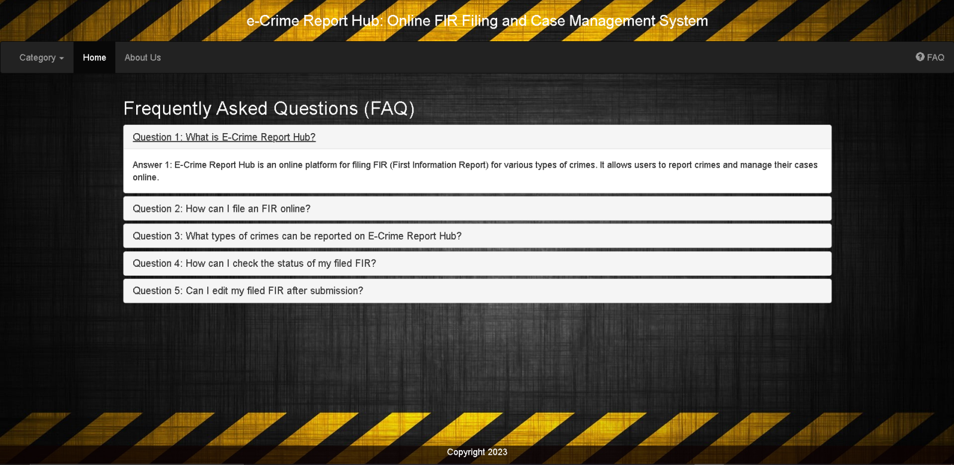

**FAQ JSP CODE:-**

<%@ page language="java" contentType="text/html; charset=ISO-8859-1"

pageEncoding="ISO-8859-1"%>

<%

String session_username = (String) session.getAttribute("session_username");

%>

<!DOCTYPE html>

<html lang="en">

<head>

<title>FAQ - E-Crime Report Hub</title>

<meta charset="utf-8">

<meta name="viewport" content="width=device-width, initial-scale=1">

<link rel="stylesheet" href="https://maxcdn.bootstrapcdn.com/bootstrap/3.4.1/css/bootstrap.min.css">

<script src="https://ajax.googleapis.com/ajax/libs/jquery/3.6.4/jquery.min.js"></script>

<script src="https://maxcdn.bootstrapcdn.com/bootstrap/3.4.1/js/bootstrap.min.js"></script>

<style>

/* Custom CSS for the body */

body {

font-family: Arial, sans-serif;

margin: 0;

padding: 0;

background-image: url('images/17.jpg');

background-size: cover;

background-repeat: no-repeat;

background-attachment: fixed;

background-position: center center;

background-color: rgba(9, 118, 165, 0.7);

}

/* Custom CSS for the "Emergency" container */

.emergency {

position: absolute;

bottom: 1px;

right: 10px;

width: 400px;

margin-bottom: 50px;

border: 1px solid #070000;

padding: 10px;

background-color: rgba(249, 249, 249, 0.7);

border-radius: 10px;

}

@media (max-width: 767px) {

.emergency {

position: static;

margin: 20px auto;

width: 90%;

}

}

.footer {

position: fixed;

left: 0;

bottom: 0;

width: 100%;

background-color: rgba(13, 2, 2, 0.7);

color: white;

text-align: center;

}

</style>

<h3 style="text-align: center; margin-bottom: 20px; color: white;">e-Crime Report Hub: Online FIR Filing and Case

Management System

</h3>

</head>

<body>

<nav class="navbar navbar-inverse">

<div class="container-fluid">

<ul class="nav navbar-nav">

<li class="dropdown"><a class="dropdown-toggle" data-toggle="dropdown" href="#">Category <span

class="caret"></span></a>

<ul class="dropdown-menu">

<li><a href="cat_theft.jsp">Theft</a></li>

<li><a href="cat_assault.jsp">Assault</a></li>

<li><a href="cat_fraud.jsp">Fraud</a></li>

<li><a href="cat_DRC.jsp">Drug-Related Crimes</a></li>

<li><a href="cat_vandalism.jsp">Vandalism</a></li>

</ul>

</li>

<!-- <li class="active"><a href="index.jsp">Home</a></li> -->

<li class="active"><a href="${session_username != null && !session_username.isEmpty() ? 'after_login.jsp' : 'index.jsp'}">Home</a></li>

<li><a href="about_us.jsp">About Us</a></li>

</ul>

<ul class="nav navbar-nav navbar-right">

<li><a href="#"><span class="glyphicon glyphicon-question-sign"></span> FAQ</a></li>

<!-- <li><a href="#"><span class="glyphicon glyphicon-log-in"></span> Login</a></li> -->

</ul>

</div>

</nav>

<div class="container">

<h2 style="color: white;" >Frequently Asked Questions (FAQ)</h2>

<div class="panel-group" id="accordion">

<!-- FAQ Section 1 -->

<div class="panel panel-default">

<div class="panel-heading">

<h4 class="panel-title">

<a data-toggle="collapse" data-parent="#accordion" href="#collapse1">

Question 1: What is E-Crime Report Hub?

</a>

</h4>

</div>

<div id="collapse1" class="panel-collapse collapse">

<div class="panel-body">

Answer 1: E-Crime Report Hub is an online platform for filing FIR (First Information Report)

for various types of crimes. It allows users to report crimes and manage their cases online.

</div>

</div>

</div>

<!-- FAQ Section 2 -->

<div class="panel panel-default">

<div class="panel-heading">

<h4 class="panel-title">

<a data-toggle="collapse" data-parent="#accordion" href="#collapse2">

Question 2: How can I file an FIR online?

</a>

</h4>

</div>

<div id="collapse2" class="panel-collapse collapse">

<div class="panel-body">

Answer 2: To file an FIR online,there are two ways: <br>

i) Visit our "Quick FIR" page, fill out the necessary details,

and submit the report. <br>

ii) Do the normal FIR filing after you're logged in into the account, here you can keep a track

of your past

complaints as well as their status.

</div>

</div>

</div>

<!-- FAQ Section 3 -->

<div class="panel panel-default">

<div class="panel-heading">

<h4 class="panel-title">

<a data-toggle="collapse" data-parent="#accordion" href="#collapse3">

Question 3: What types of crimes can be reported on E-Crime Report Hub?

</a>

</h4>

</div>

<div id="collapse3" class="panel-collapse collapse">

<div class="panel-body">

Answer 3: E-Crime Report Hub allows you to report various types of crimes, including theft,

assault, fraud, drug-related crimes, vandalism, and more. Select the appropriate category when

filing your report.

</div>

</div>

</div>

<!-- FAQ Section 4 -->

<div class="panel panel-default">

<div class="panel-heading">

<h4 class="panel-title">

<a data-toggle="collapse" data-parent="#accordion" href="#collapse4">

Question 4: How can I check the status of my filed FIR?

</a>

</h4>

</div>

<div id="collapse4" class="panel-collapse collapse">

<div class="panel-body">

Answer 4: You can check the status of your filed FIR by logging into your account on

E-Crime Report Hub and visiting the "My Complaints" section. There, you will find updates on

the progress of your case.

</div>

</div>

</div>

<!-- FAQ Section 5 -->

<div class="panel panel-default">

<div class="panel-heading">

<h4 class="panel-title">

<a data-toggle="collapse" data-parent="#accordion" href="#collapse5">

Question 5: Can I edit my filed FIR after submission?

</a>

</h4>

</div>

<div id="collapse5" class="panel-collapse collapse">

<div class="panel-body">

Answer 5: No, once you have submitted your FIR online, you cannot edit it. If you need to

make changes or provide additional information, please contact your local police station or

the relevant authorities.

</div>

</div>

</div>

</div>

</div>

<div class="footer">

<p>Copyright 2023</p>

</div>

</body>

</html>

**ABOUT US PAGE :**-

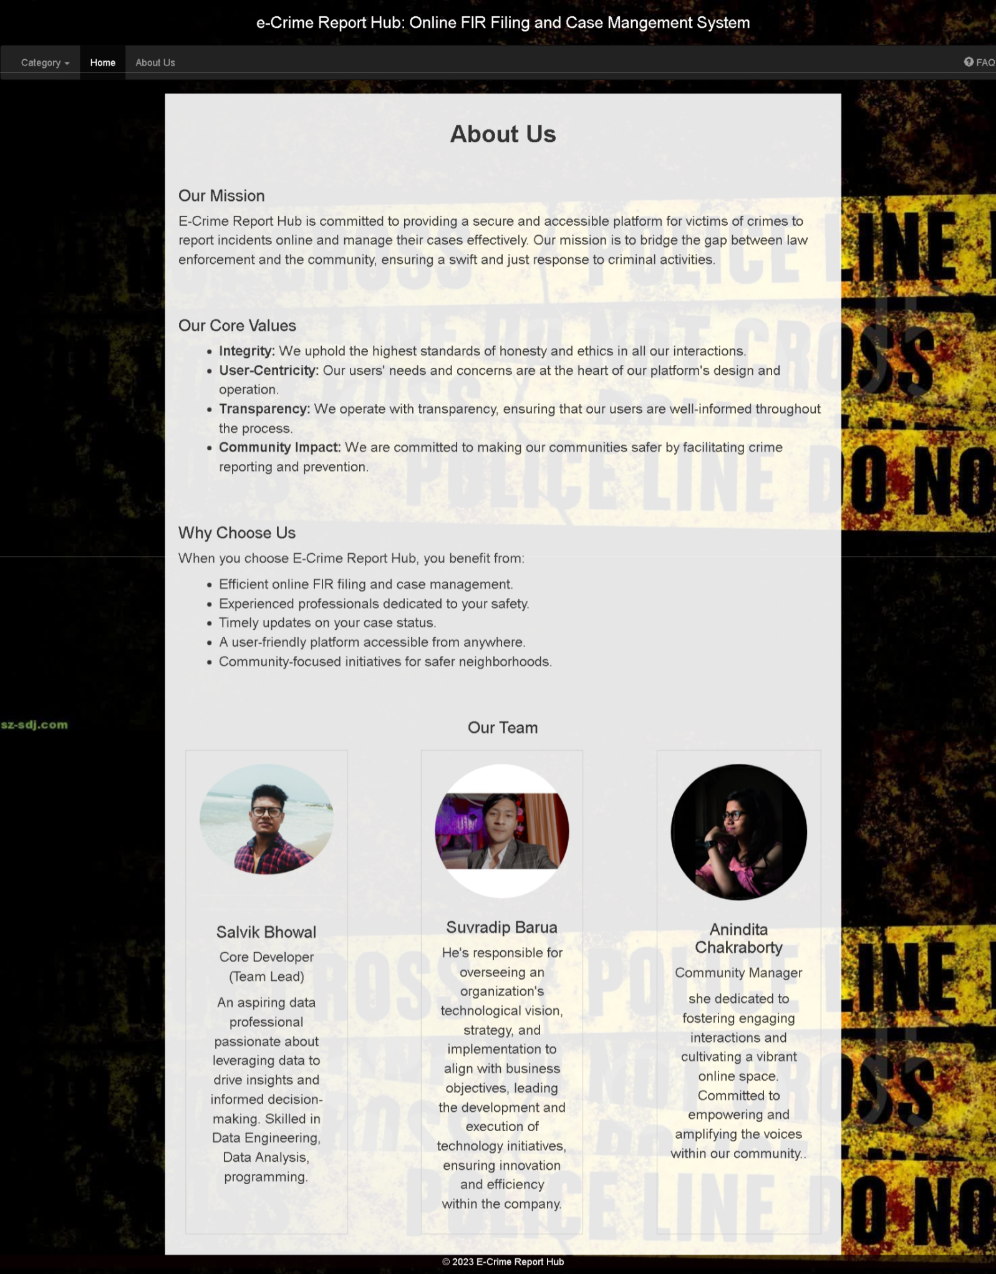

**ABOUT US JSP CODE:**

<%@ page language="java" contentType="text/html; charset=ISO-8859-1"

pageEncoding="ISO-8859-1"%>

<%

String session_username = (String) session.getAttribute("session_username");

%>

<!DOCTYPE html>

<html lang="en">

<head>

<meta charset="UTF-8">

<meta name="viewport" content="width=device-width, initial-scale=1.0">

<!-- <link rel="stylesheet" href="https://maxcdn.bootstrapcdn.com/bootstrap/3.4.1/css/bootstrap.min.css"> -->

<link rel="stylesheet" href="https://maxcdn.bootstrapcdn.com/bootstrap/3.4.1/css/bootstrap.min.css">

<script src="https://ajax.googleapis.com/ajax/libs/jquery/3.6.4/jquery.min.js"></script>

<script src="https://maxcdn.bootstrapcdn.com/bootstrap/3.4.1/js/bootstrap.min.js"></script>

<title>About Us - E-Crime Report Hub</title>

<style>

/* Custom CSS for the body */

body {

font-family: Arial, sans-serif;

margin: 0;

padding: 0;

background-image: url('images/2.jpg' );

background-size: cover;

background-repeat: repeat;

background-attachment: fixed;

background-position: center center;

background-color: rgba(9, 118, 165, 0.7);

color: #333;

}

/* Header styles */

header {

text-align: center;

margin-top: 10px;

}

header h1 {

font-size: 36px;

color: white;

}

/* Container styles */

.container {

max-width: 1000px;

margin: 0 auto;

padding: 20px;

background-color: rgba(255, 255, 255, 0.9);

font-size: 20px;

}

/* Section title styles */

h2 {

font-size: 24px;

margin-top: 20px;

}

/* List styles */

ul {

list-style: disc;

margin-left: 20px;

}

/* Team member styles */

.team-member {

margin-top: 20px;

text-align: center;

border: 1px solid #ccc;

padding: 20px;

margin: 10px;

flex: 0 0 calc(30% - 20px);

/* Adjusted width for desktop */

}

.team-member img {

max-width: 100%;

height: auto;

border-radius: 50%;

margin-bottom: 10px;

}

/* Media query for mobile devices */

@media (max-width: 768px) {

.team-members {

flex-direction: column;

/* Display members in a vertical column */

}

.team-member {

flex: 0 0 100%;

/* Full width for mobile */

}

}

</style>

<h3 style="text-align: center; margin-bottom: 20px; color: white;">e-Crime Report Hub: Online FIR Filing and Case

Mangement System

</h3>

</head>

<body>

<nav class="navbar navbar-inverse">

<div class="container-fluid">

<ul class="nav navbar-nav">

<li class="dropdown"><a class="dropdown-toggle" data-toggle="dropdown" href="#">Category <span

class="caret"></span></a>

<ul class="dropdown-menu">

<li><a href="cat_theft.jsp">Theft</a></li>

<li><a href="cat_assault.jsp">Assault</a></li>

<li><a href="cat_fraud.jsp">Fraud</a></li>

<li><a href="cat_DRC.jsp">Drug-Related Crimes</a></li>

<li><a href="cat_vandalism.jsp">Vandalism</a></li>

</ul>

</li>

<!-- <li class="active"><a href="index.jsp">Home</a></li>-->

<li class="active"><a href="${session_username != null && !session_username.isEmpty() ? 'after_login.jsp' : 'index.jsp'}">Home</a></li>

<!-- <li class="active"><a href="${session.getAttribute('session_username') != null ? 'after_login.jsp' : 'index.jsp'}">Home</a></li> -->

<li><a href="about_us.jsp">About Us</a></li>

</ul>

<ul class="nav navbar-nav navbar-right">

<li><a href="FAQ.jsp"><span class="glyphicon glyphicon-question-sign"></span> FAQ</a></li>

</ul>

</div>

</nav>

<header>

<!-- <h1 style= font-weight:bold;>About Us</h1> -->

</header>

<section class="mission">

<div class="container">

<h1 style= font-weight:bold;text-align:center;>About Us</h1>

<br>

<h2>Our Mission</h2>

<p>

E-Crime Report Hub is committed to providing a secure and accessible platform for victims of crimes to

report incidents online and manage their cases effectively. Our mission is to bridge the gap between law

enforcement and the community, ensuring a swift and just response to criminal activities.

</p>

</div>

</section>

<section class="values">

<div class="container">

<h2>Our Core Values</h2>

<ul>

<li><strong>Integrity:</strong> We uphold the highest standards of honesty and ethics in all our

interactions.</li>

<li><strong>User-Centricity:</strong> Our users' needs and concerns are at the heart of our platform's

design and operation.</li>

<li><strong>Transparency:</strong> We operate with transparency, ensuring that our users are

well-informed throughout the process.</li>

<li><strong>Community Impact:</strong> We are committed to making our communities safer by facilitating

crime reporting and prevention.</li>

</ul>

</div>

</section>

<section class="why-choose-us">

<div class="container">

<h2>Why Choose Us</h2>

<p>

When you choose E-Crime Report Hub, you benefit from:

</p>

<ul>

<li>Efficient online FIR filing and case management.</li>

<li>Experienced professionals dedicated to your safety.</li>

<li>Timely updates on your case status.</li>

<li>A user-friendly platform accessible from anywhere.</li>

<li>Community-focused initiatives for safer neighborhoods.</li>

</ul>

</div>

</section>

<section class="team">

<div class="container">

<h2 style="text-align: center;">Our Team</h2>

<div class="team-members" style="display: flex; justify-content: space-between; flex-wrap: wrap;">

<!-- Added flex-wrap -->

<div class="team-member" style="flex: 0 0 25%; border: 1px solid #ccc; padding: 20px; margin: 10px;">

<img src="images/salvik4.5.jpg" alt="John Doe">

<hr>

<hr>

<h3>Salvik Bhowal</h3>

<p>Core Developer <br>

(Team Lead)</p>

<p>An aspiring data professional passionate about leveraging data to drive insights and informed decision-making. Skilled in Data Engineering, Data Analysis, programming.

</p>

</div>

<div class="team-member" style="flex: 0 0 25%; border: 1px solid #ccc; padding: 20px; margin: 10px;">

<img src="images/sbarua.jpg" alt="Jane Smith">

<h3>Suvradip Barua</h3>

<p> He's responsible for overseeing an organization's technological vision, strategy, and implementation to align with business objectives, leading the development and execution of technology initiatives, ensuring innovation and efficiency within the company.</p>

</div>

<div class="team-member" style="flex: 0 0 25%; border: 1px solid #ccc; padding: 20px; margin: 10px;">

<img src="images/ani.jpg" alt="Emily Brown">

<h3>Anindita Chakraborty</h3>

<p>Community Manager</p>

<p>she dedicated to fostering engaging interactions and cultivating a vibrant online space. Committed to empowering and amplifying the voices within our community..</p>

</div>

</div>

</div>

</section>

<script>

// Get the referrer URL

var referrer = document.referrer;

// Check if the referrer is index.jsp

if (referrer.endsWith("index.jsp")) {

// User came from index.jsp, so enable the Home button to return to index.jsp

var homeButton = document.querySelector("a[href='index.jsp']");

if (homeButton) {

homeButton.addEventListener("click", function (e) {

e.preventDefault(); // Prevent the default link behavior

window.location.href = "index.jsp"; // Redirect to index.jsp

});

}

}

</script>

</body>

<footer style="position: auto; left: 0; bottom: 0; width: 100%; background-color: rgba(13, 2, 2, 0.7); color: white; text-align: center;">

<p>&copy; 2023 E-Crime Report Hub</p>

</footer>

</html>

**CATEGORY PAGES :**-

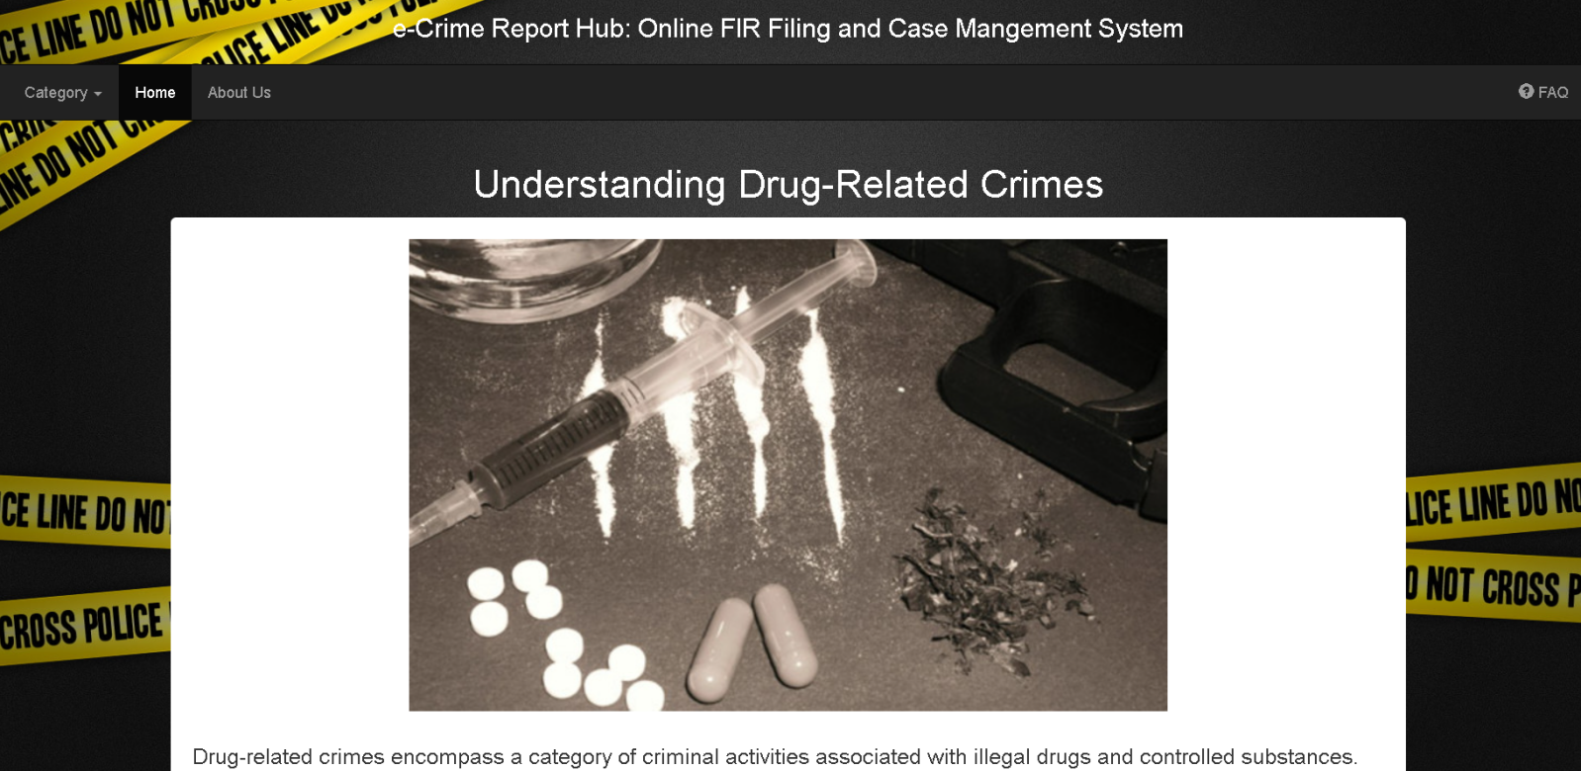

**CATEGORY JSP CODE :**-

<%@ page language="java" contentType="text/html; charset=ISO-8859-1"

pageEncoding="ISO-8859-1"%>

<%

String session_username = (String) session.getAttribute("session_username");

%>

<!DOCTYPE html>

<html lang="en">

<head>

<title>Drug-Related Crimes</title>

<meta charset="utf-8">

<meta name="viewport" content="width=device-width, initial-scale=1">

<link rel="stylesheet" href="https://maxcdn.bootstrapcdn.com/bootstrap/3.4.1/css/bootstrap.min.css">

<style>

/* Custom CSS for the body */

body {

font-family: Arial, sans-serif;

margin: 0;

padding: 0;

background-size: cover;

background-image: url('images/16.jpg');

background-repeat: no-repeat;

background-attachment: fixed;

background-position: center center;

background-color: rgba(9, 118, 165, 0.2);

}

/* Style for the title */

.title {

text-align: center;

margin-top: 10px;

font-size: 36px;

color: white;

}

/* Style for the content */

.content {

max-width: auto;

margin: auto;

padding: 20px;

background-color: white;

border-radius: 5px;

color: #333;

}

.top-image {

text-align: center;

}

.top-image img {

max-width: 100%;

height: auto;

}

.content {

font-size: 20px;

}

</style>

</head>

<head>

<title>E-Crime Report Hub</title>

<meta charset="utf-8">

<meta name="viewport" content="width=device-width, initial-scale=1">

<link rel="stylesheet" href="https://maxcdn.bootstrapcdn.com/bootstrap/3.4.1/css/bootstrap.min.css">

<script src="https://ajax.googleapis.com/ajax/libs/jquery/3.6.4/jquery.min.js"></script>

<script src="https://maxcdn.bootstrapcdn.com/bootstrap/3.4.1/js/bootstrap.min.js"></script>

<style>

/* Custom CSS for the body */

body {

font-family: Arial, sans-serif;

margin: 0;

padding: 0;

/* background-image: url('g1.jpg'); */

/* Replace 'your-image-url.jpg' with your image URL */

background-size: cover;

background-repeat: no-repeat;

background-attachment: fixed;

background-position: center center;

background-color: rgba(9, 118, 165, 0.7);

/* Background color with transparency */

}

/* Custom CSS for the "Emergency" container */

.emergency {

position: absolute;

bottom: 1px;

right: 10px;

width: 400px;

margin-bottom: 50px;

border: 1px solid #070000;

padding: 10px;

background-color: rgba(249, 249, 249, 0.7);

/* Adjusted background color with transparency */

border-radius: 10px;

}

@media (max-width: 767px) {

/* Media query for screens smaller than 768px (phones) */

.emergency {

position: static;

/* Remove absolute positioning */

margin: 20px auto;

/* Center the container horizontally */

width: 90%;

/* Adjust the width for smaller screens */

}

}

.footer {

position:auto;

left: 0;

bottom: 10px;

width: 100%;

background-color: rgba(13, 2, 2, 0.7);

color: white;

text-align: center;

}

</style>

<h3 style="text-align: center; margin-bottom: 20px; color: white;">e-Crime Report Hub: Online FIR Filing and Case

Mangement System

</h3>

</head>

<body>

<nav class="navbar navbar-inverse">

<div class="container-fluid">

<ul class="nav navbar-nav">

<li class="dropdown"><a class="dropdown-toggle" data-toggle="dropdown" href="#">Category <span

class="caret"></span></a>

<ul class="dropdown-menu">

<li><a href="cat_theft.jsp">Theft</a></li>

<li><a href="cat_assault.jsp">Assault</a></li>

<li><a href="cat_fraud.jsp">Fraud</a></li>

<li><a href="cat_DRC.jsp">Drug-Related Crimes</a></li>

<li><a href="cat_vandalism.jsp">Vandalism</a></li>

</ul>

</li>

<li class="active"><a href="${session_username != null && !session_username.isEmpty() ? 'after_login.jsp' : 'index.jsp'}">Home</a></li>

<li><a href="about_us.jsp">About Us</a></li>

</ul>

<ul class="nav navbar-nav navbar-right">

<li><a href="FAQ.jsp"><span class="glyphicon glyphicon-question-sign"></span> FAQ</a></li>

<!-- <li><a href="#"><span class="glyphicon glyphicon-log-in"></span> Login</a></li> -->

</ul>

</div>

</nav>

<body>

<div class="container">

<div class="title">

<h1>Understanding Theft</h1>

</div>

<div class="content">

<div class="top-image">

<img src="images/cat_theft_img.jpg"

alt="Theft Image">

</div>

<br>

<p>

<b>Theft</b> is a criminal act that involves taking someone else's property without their consent with

the

intention of permanently depriving them of it. It's a common crime worldwide and can encompass a range

of illegal activities. Here's a detailed explanation of theft, including its types:

</p>

<br>

<p><b style="font-size: 25px;">What is Theft?</b></p>

<p>

Theft is a property crime that involves unlawfully taking or appropriating someone else's belongings or

assets without their permission. This act violates a person's right to possess and enjoy their property,

and it's considered a criminal offense in most legal systems. Theft can involve various items, including

money, electronics, vehicles, jewelry, and more.

</p>

<br>

<p><b style="font-size: 25px;">Elements of Theft:</b></p>

<p>To constitute theft, several key elements must be present:</p>

<p>

<b>1.Taking:</b>: The offender must physically or fraudulently take possession of another person's

property. This includes scenarios like pickpocketing, shoplifting, and breaking into someone's home.

</p>

<p>

<b>2.Without Consent: </b>: The property must be taken without the consent or permission of the owner.

Consent can be explicit or implied. For example, borrowing a friend's book with their permission is not

theft, but taking it without their knowledge or approval is.

<p>

<b>3.Intent:</b>: The perpetrator must have the intent to permanently deprive the owner of their

property. Temporary possession, such as borrowing with the intention to return, doesn't constitute

theft.

</p>

<br>

<p><b style="font-size: 25px;">Types of Theft:</b></p>

<p>Theft comes in various forms, each categorized based on specific circumstances or characteristics of the

crime. Common types of theft include:</p>

<br>

<p>

<b>1.Petty Theft:</b>: Also known as larceny, this involves the theft of low-value items. It's typically

considered a misdemeanor, with less severe penalties compared to grand theft.

</p>

<p>

<b>2.Grand Theft: </b>: Grand theft involves the theft of higher-value items, often classified based on

a specific dollar threshold. It is considered a felony in many jurisdictions and carries more severe

punishments.

</p>

<p>

<b>3.Shoplifting:</b>: This type of theft occurs in retail stores when individuals steal merchandise. It

can involve concealing items, switching price tags, or leaving without paying.

</p>

<p>

<b>4.Auto Theft:</b>: Stealing motor vehicles, such as cars, motorcycles, or trucks, is a common form of

theft. It may also be referred to as carjacking when force or threats are used to take the vehicle.

</p>

<p>

<b>5.Burglary:</b>: Unlike theft, burglary involves illegally entering a building or property with the

intent to commit theft or other crimes. The act of breaking and entering is a crucial component of

burglary.

</p>

<p>

<b>6.Robbery:</b>: Robbery is a more serious crime that involves theft with the use of force,

intimidation, or violence. It typically occurs in person-to-person confrontations, such as muggings.

</p>

<p>

<b>7.Embezzlement:</b>:This is a form of theft where an individual misappropriates funds or property

entrusted to them, often in an employment or fiduciary capacity.

</p>

<p>

<b>8.Identity Theft: </b>:Identity theft occurs when someone steals another person's personal

information, such as Social Security numbers or credit card details, to commit fraudulent activities or

financial theft.

</p>

<p>

<b>9.Cyber Theft: </b>In the digital age, theft can extend to cybercrimes, including hacking, phishing,

and online scams aimed at stealing sensitive information or funds.

</p>

<p>

<b>10.Employee Theft: </b>This involves employees stealing from their employers, such as taking office

supplies, embezzling funds, or stealing company property.

</p>

<br>

<p><b style="font-size: 25px;">Legal Consequences:</b> </p>

<p>The legal consequences for theft vary depending on the jurisdiction and the severity of the crime.

Penalties may include fines, probation, community service, restitution to victims, and imprisonment.

Repeat offenders or those involved in more serious theft crimes are likely to face more severe

punishments.</p>

<br>

<p>It's essential to recognize that theft is a crime with real consequences, and society relies on laws and

law enforcement agencies to deter and address theft in its various forms.</p>

</div>

</div>

<div class="footer">

<p>Copyright 2023</p>

</div>

</body>

</html>

**AFTER LOGIN PAGE :**-

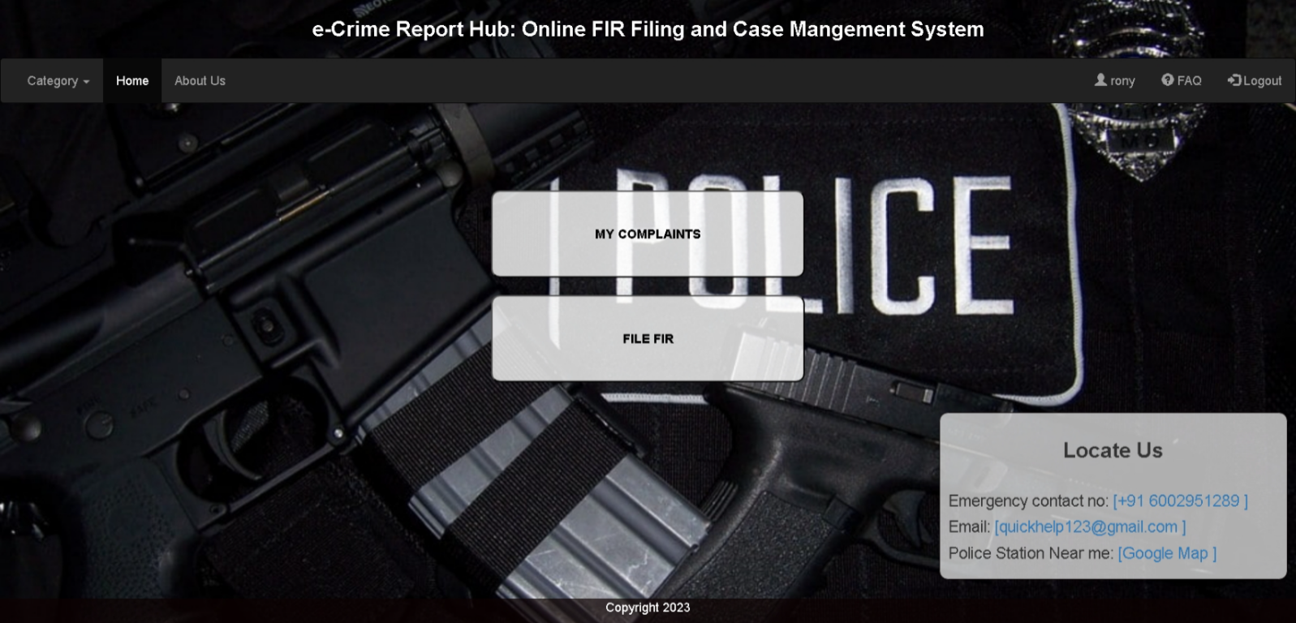

**AFTER LOGIN JSP CODE:**

<%@ page language="java" contentType="text/html; charset=ISO-8859-1"

pageEncoding="ISO-8859-1"%>

<!DOCTYPE html>

<html lang="en">

<head>

<title>E-Crime Report Hub / after login</title>

<meta charset="utf-8">

<meta name="viewport" content="width=device-width, initial-scale=1">

<link rel="stylesheet" href="https://maxcdn.bootstrapcdn.com/bootstrap/3.4.1/css/bootstrap.min.css">

<script src="https://ajax.googleapis.com/ajax/libs/jquery/3.6.4/jquery.min.js"></script>

<script src="https://maxcdn.bootstrapcdn.com/bootstrap/3.4.1/js/bootstrap.min.js"></script>

<style>

/* Custom CSS for the body */

body {

font-family: Arial, sans-serif;

margin: 0;

padding: 0;

background-image: url('images/15.jpg');

/* Replace 'your-image-url.jpg' with your image URL */

background-size: cover;

background-repeat: no-repeat;

background-attachment: fixed;

background-position: center center;

background-color: rgba(9, 118, 165, 0.7);

/* Background color with transparency */

}

/* Custom CSS for the "Emergency" container */

.emergency {

position: absolute;

bottom: 1px;

right: 10px;

width: 400px;

margin-bottom: 50px;

border: 1px solid #070000;

padding: 10px;

background-color: rgba(249, 249, 249, 0.7);

/* Adjusted background color with transparency */

border-radius: 10px;

}

@media (max-width: 767px) {

/* Media query for screens smaller than 768px (phones) */

.emergency {

position: static;

/* Remove absolute positioning */

margin: 20px auto;

/* Center the container horizontally */

width: 90%;

/* Adjust the width for smaller screens */

}

}

.footer {

position: fixed;

left: 0;

bottom: 0;

width: 100%;

background-color: rgba(13, 2, 2, 0.7);

color: white;

text-align: center;

}

</style>

<h3 style="text-align: center;font-weight:bold; margin-bottom: 20px; color: white;">e-Crime Report Hub: Online FIR Filing and Case

Mangement System

</h3>

</head>

<body>

<nav class="navbar navbar-inverse">

<div class="container-fluid">

<ul class="nav navbar-nav">

<li class="dropdown"><a class="dropdown-toggle" data-toggle="dropdown" href="#">Category <span

class="caret"></span></a>

<ul class="dropdown-menu">

<li><a href="cat_theft.jsp">Theft</a></li>

<li><a href="cat_assault.jsp">Assault</a></li>

<li><a href="cat_fraud.jsp">Fraud</a></li>

<li><a href="cat_DRC.jsp">Drug-Related Crimes</a></li>

<li><a href="cat_vandalism.jsp">Vandalism</a></li>

</ul>

</li>

<li class="active"><a href="after_login.jsp">Home</a></li>

<li><a href="about_us.jsp">About Us</a></li>

</ul>

<ul class="nav navbar-nav navbar-right">

<li><a href="#"><span class="glyphicon glyphicon-user"></span> ${session_username }</a></li>

<li><a href="FAQ.jsp"><span class="glyphicon glyphicon-question-sign"></span> FAQ</a></li>

<!-- <li><a href="index.jsp"><span class="glyphicon glyphicon-log-in"></span> Logout</a></li> -->

<!-- <li><a href="index.jsp" onclick="logout();"><span class="glyphicon glyphicon-log-in"></span> Logout</a></li> -->

<!-- <li><a href="LogoutServlet" ><span class="glyphicon glyphicon-log-in"></span> Logout</a></li>-->

<li><a href="LogoutServlet" id="logoutButton"><span class="glyphicon glyphicon-log-in"></span> Logout</a></li>

</ul>

</div>

</nav>

<div class="container">

<div class="row">

<div class="col-xs-12 col-sm-6 col-sm-offset-3 col-md-4 col-md-offset-4">

<div class="Qfir">

<center>

<a href="mycomplaints.jsp">

<button style="width: 100%;color:black;font-weight:bold; height: 100px; margin-top: 80px; background-color: rgba(255, 255, 255, 0.8); border-radius: 10px;">

MY COMPLAINTS

</button>

</a>

</center>

</div>

<div class="Qfir">

<center>

<a href="filefir.jsp">

<button style="width: 100%;color:black;font-weight:bold; height: 100px; margin-top: 20px; background-color: rgba(255, 255, 255, 0.8); border-radius: 10px;">

FILE FIR

</button>

</a>

</center>

</div>

</div>

</div>

</div>

<div class="emergency">

<h3 style="text-align: center; margin-bottom: 35px; font-weight:bold;" >Locate Us</h3>

<p>

<h4>Emergency contact no: <a href="#">[+91 6002951289 ]</a></h4>

</p>

<p>

<h4>Email: <a href="#">[quickhelp123@gmail.com ]</a> </h4>

</p>

<p>

<h4>Police Station Near me: <a href="#">[Google Map ]</a> </h4>

</p>

</div>

<div class="footer">

<p>Copyright 2023</p>

</div>

<script>

var sessionTimeout;

function resetSessionTimeout() {

clearTimeout(sessionTimeout);

sessionTimeout = setTimeout(function() {

// Redirect to a logout or session timeout page

window.location.href = "logout.jsp";

}, 300000); // 300,000 milliseconds = 5 minutes

}

// Add event listeners to reset the timer when there's user activity

document.addEventListener("mousemove", resetSessionTimeout);

document.addEventListener("keydown", resetSessionTimeout);

// Initialize the session timeout when the page loads

resetSessionTimeout();

</script>

<script>

//added JavaScript to trigger a logout when the session times out. For example, if the session timeout occurs and the user is on the after_login.jsp page, you can automatically log them out by simulating a click on the logout button.

var sessionTimeout;

function resetSessionTimeout() {

clearTimeout(sessionTimeout);

sessionTimeout = setTimeout(function() {

// Simulate a click on the logout button when the session times out

document.getElementById("logoutButton").click();

}, 300000); // 300,000 milliseconds = 5 minutes

}

// Add event listeners to reset the timer when there's user activity

document.addEventListener("mousemove", resetSessionTimeout);

document.addEventListener("keydown", resetSessionTimeout);

// Initialize the session timeout when the page loads

resetSessionTimeout();

</script>

</body>

</html>

**MY COMPLAINTS PAGE :**-

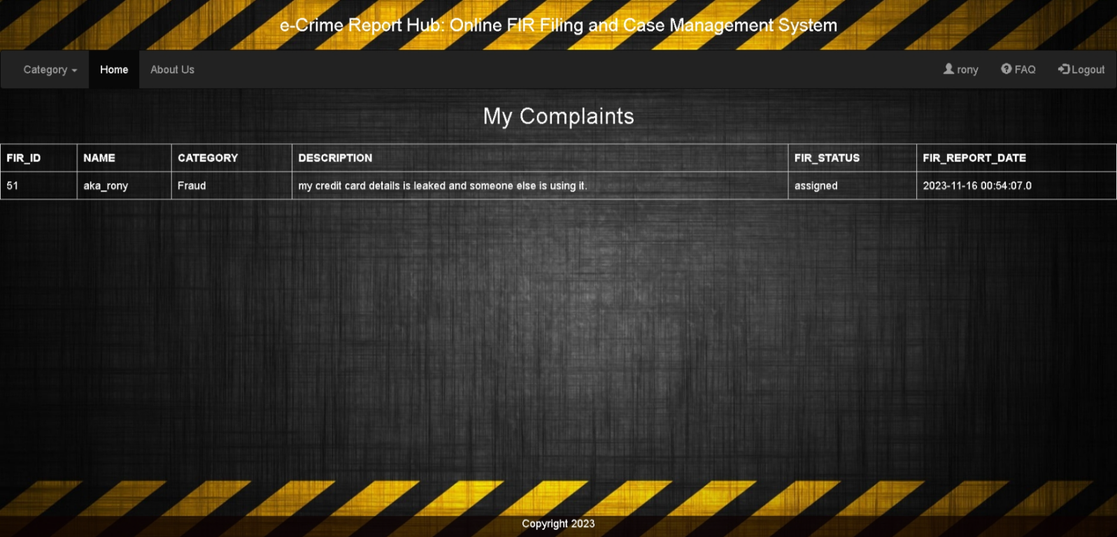

MY COMPLAINTS JSP CODE :-

<%@ page contentType="text/html; charset=UTF-8" %>

<%@ taglib uri="http://java.sun.com/jsp/jstl/core" prefix="c" %>

<%@ taglib uri="http://java.sun.com/jsp/jstl/sql" prefix="sql" %>

<%@ page import="java.sql.*" %>

<!DOCTYPE html>

<html>

<head>

<title>E-Crime Report Hub / My Complaints</title>

<meta charset="utf-8">

<meta name="viewport" content="width=device-width, initial-scale=1">

<link rel="stylesheet" href="https://maxcdn.bootstrapcdn.com/bootstrap/3.4.1/css/bootstrap.min.css">

<script src="https://ajax.googleapis.com/ajax/libs/jquery/3.6.4/jquery.min.js"></script>

<script src="https://maxcdn.bootstrapcdn.com/bootstrap/3.4.1/js/bootstrap.min.js"></script>

<style>

/* Custom CSS for the body */

body {

font-family: Arial, sans-serif;

margin: 0;

padding: 0;

background-image: url('images/17.jpg');

/* Replace 'your-image-url.jpg' with your image URL */

background-size: cover;

background-repeat: no-repeat;

background-attachment: fixed;

background-position: center center;

background-color: rgba(9, 118, 165, 0.7);

/* Background color with transparency */

}

/* Custom CSS for the "Emergency" container */

.emergency {

position: absolute;

bottom: 1px;

right: 10px;

width: 400px;

margin-bottom: 50px;

border: 1px solid #070000;

padding: 10px;

background-color: rgba(249, 249, 249, 0.7);

/* Adjusted background color with transparency */

border-radius: 10px;

}

@media (max-width: 767px) {

/* Media query for screens smaller than 768px (phones) */

.emergency {

position: static;

/* Remove absolute positioning */

margin: 20px auto;

/* Center the container horizontally */

width: 90%;

/* Adjust the width for smaller screens */

}

}

.footer {

position: fixed;

left: 0;

bottom: 0;

width: 100%;

background-color: rgba(13, 2, 2, 0.7);

color: white;

text-align: center;

}

/* Style for the complaint section */

.complaint {

border: 1px solid #ccc;

padding: 10px;

margin-bottom: 20px;

background-color: rgba(255, 255, 255, 0.8);

border-radius: 10px;

}

.complaint h3 {

margin-top: 0;

}

.status {

font-weight: bold;

}

/* Additional styles for different status */

.status-solved {

color: green;

}

.status-pending {

color: orange;

}

.status-processing {

color: blue;

}

.table td {

color: white;

}

.b1 {

font-weight: bold;

color: black;

}

</style>

<h3 style="text-align: center; margin-bottom: 20px; color: white;">e-Crime Report Hub: Online FIR Filing and Case

Management System

</h3>

</head>

<body>

<nav class="navbar navbar-inverse">

<div class="container-fluid">

<ul class="nav navbar-nav">

<li class="dropdown"><a class="dropdown-toggle" data-toggle="dropdown" href="#">Category <span

class="caret"></span></a>

<ul class="dropdown-menu">

<li><a href="cat_theft.jsp">Theft</a></li>

<li><a href="cat_assault.jsp">Assault</a></li>

<li><a href="cat_fraud.jsp">Fraud</a></li>

<li><a href="cat_DRC.jsp">Drug-Related Crimes</a></li>

<li><a href="cat_vandalism">Vandalism</a></li>

</ul>

</li>

<li class="active"><a href="after_login.jsp">Home</a></li>

<li><a href="about_us.jsp">About Us</a></li>

</ul>

<ul class="nav navbar-nav navbar-right">

<li><a href="#"><span class="glyphicon glyphicon-user"></span> ${session_username }</a></li>

<li><a href="FAQ.jsp"><span class="glyphicon glyphicon-question-sign"></span> FAQ</a></li>

<li><a href="index.jsp"><span class="glyphicon glyphicon-log-in"></span> Logout</a></li>

</ul>

</div>

</nav>

<h2 style="text-align: center; margin-bottom: 20px; color: white;">My Complaints </h3>

<sql:setDataSource

var="ds"

driver="com.mysql.jdbc.Driver"

url="jdbc:mysql://localhost:3306/ecrh"

user="root"

password="rony"

/>

<c:set var="userEmail" value="${sessionScope.user_email}" />

<sql:query dataSource="${ds}" var="rs">

SELECT fir_id, name, category, description, FIR_status, FIR_REPORT_DATE

FROM after_login_fir

WHERE user_email = '${user_email}'

</sql:query>

<div class="table-responsive">

<table class="table table-bordered">

<tr class="b1">

<td>FIR_ID</td>

<td>NAME</td>

<td>CATEGORY</td>

<td>DESCRIPTION</td>

<td>FIR_STATUS</td>

<td>FIR_REPORT_DATE</td>

</tr>

<c:forEach var="row" items="${rs.rows}">

<tr>

<td><c:out value="${row.fir_id}"/></td>

<td><c:out value="${row.name}"/></td>

<td><c:out value="${row.category}"/></td>

<td><c:out value="${row.description}"/></td>

<td><c:out value="${row.FIR_status}"/></td>

<td><c:out value="${row.FIR_REPORT_DATE}"/></td>

</tr>

</c:forEach>

</table>

</div>

<div class="footer">

<p>Copyright 2023</p>

</div>

</body>

</html>

**FILE FIR PAGE :**-

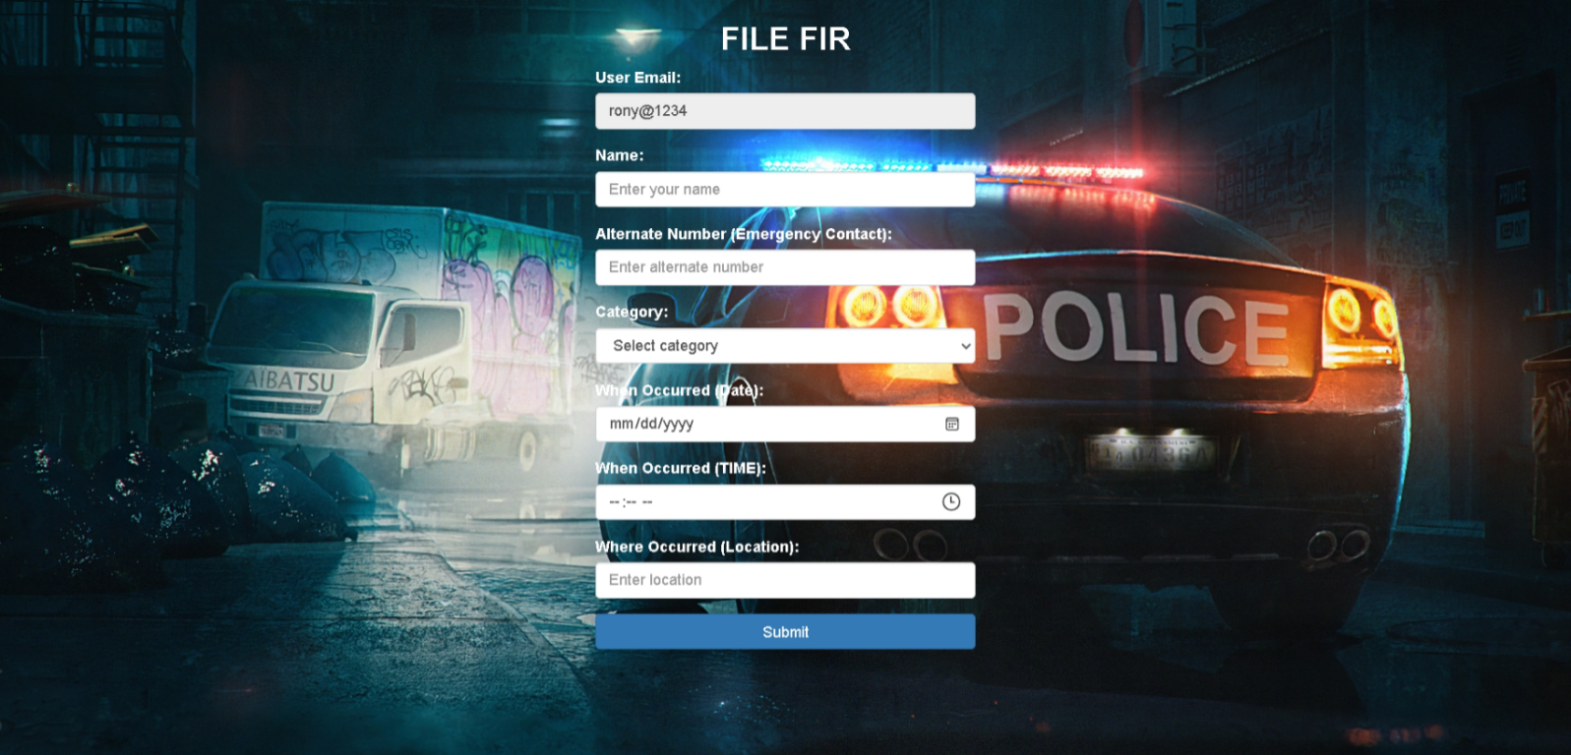

FILE FIR JSP CODE:-

<%@ page language="java" contentType="text/html; charset=ISO-8859-1"

pageEncoding="ISO-8859-1"%>

<!DOCTYPE html>

<html lang="en">

<head>

<title>FILE FIR</title>

<meta charset="utf-8">

<meta name="viewport" content="width=device-width, initial-scale=1">

<link rel="stylesheet" href="https://maxcdn.bootstrapcdn.com/bootstrap/3.4.1/css/bootstrap.min.css">

<script src="https://ajax.googleapis.com/ajax/libs/jquery/3.6.4/jquery.min.js"></script>

<script src="https://maxcdn.bootstrapcdn.com/bootstrap/3.4.1/js/bootstrap.min.js"></script>

</head>

<style>

body {

font-family: Arial, sans-serif;

margin: 0;

padding: 0;

background-size: cover;

background-image: url('images/12.jpg');

background-repeat: no-repeat;

background-attachment: fixed;

background-position: center center;

background-color: rgba(9, 118, 165, 0.7);

}

label{

color: white;

}

</style>

<body>

<div class="container">

<div class="row">

<div class="col-xs-12 col-sm-6 col-sm-offset-3 col-md-4 col-md-offset-4">

<h2 style="text-align: center; color:white; font-weight: bold;">FILE FIR</h2>

<form action="FileFIR" method="post">

<div class="form-group">

<!-- Display the user email from the session -->

<label for="userEmail">User Email:</label>

<input type="text" class="form-control" id="userEmail" name="userEmail" value="<%= session.getAttribute("user_email") %>" readonly>

<!-- Add a hidden field to send user email to the server -->

<input type="hidden" id="hiddenUserEmail" name="hiddenUserEmail" value="<%= session.getAttribute("user_email") %>">

</div>

<div class="form-group">

<label for="name">Name:</label>

<input type="text" class="form-control" id="name" name="name" placeholder="Enter your name" required>

</div>

<div class="form-group">

<label for="emergencyContact">Alternate Number (Emergency Contact):</label>

<input type="tel" class="form-control" id="emergencyContact" name="emergencyContact" placeholder="Enter alternate number" required>

</div>

<div class="form-group">

<label for="category">Category:</label>

<select class="form-control" id="category" name="category" required>

<option value="">Select category</option>

<option value="Theft">Theft</option>

<option value="Assault">Assault</option>

<option value="Fraud">Fraud</option>

<option value="Drug-Related Crimes">Drug-Related Crimes</option>

<option value="Vandalism">Vandalism</option>

<option value="Others">Others</option>

</select>

</div>

<div class="form-group" id="incidentDescriptionGroup" style="display: none;">

<label for="description">Incident Description:</label>

<textarea class="form-control" id="description" name="description" rows="4" placeholder="Enter incident description"></textarea>

</div>

<div class="form-group">

<label for="date">When Occurred (Date):</label>

<input type="date" class="form-control" id="date" name="date" required>

</div>

<div class="form-group">

<label for "whenOccurred">When Occurred (TIME):</label>

<input type="time" class="form-control" id="whenOccurredTime" name="whenOccurredTime" required>

</div>

<div class="form-group">

<label for="location">Where Occurred (Location):</label>

<input type="text" class="form-control" id="location" name="location" placeholder="Enter location" required>

</div>

<button type="submit" class="btn btn-primary btn-block">Submit</button>

</form>

</div>

</div>

</div>

<script>

$(document).ready(function () {

$("#category").change(function () {

var selectedCategory = $(this).val();

var incidentDescriptionGroup = $("#incidentDescriptionGroup");

if (selectedCategory !== "") {

incidentDescriptionGroup.show();

} else {

incidentDescriptionGroup.hide();

}

});

});

</script>

</body>

</html>

**FILE FIR SERVLET CODE:-**

<%@ page language="java" contentType="text/html; charset=ISO-8859-1"

pageEncoding="ISO-8859-1"%>

<!DOCTYPE html>

<html lang="en">

<head>

<title>FILE FIR</title>

<meta charset="utf-8">

<meta name="viewport" content="width=device-width, initial-scale=1">

<link rel="stylesheet" href="https://maxcdn.bootstrapcdn.com/bootstrap/3.4.1/css/bootstrap.min.css">

<script src="https://ajax.googleapis.com/ajax/libs/jquery/3.6.4/jquery.min.js"></script>

<script src="https://maxcdn.bootstrapcdn.com/bootstrap/3.4.1/js/bootstrap.min.js"></script>

</head>

<style>

body {

font-family: Arial, sans-serif;

margin: 0;

padding: 0;

background-size: cover;

background-image: url('images/12.jpg');

background-repeat: no-repeat;

background-attachment: fixed;

background-position: center center;

background-color: rgba(9, 118, 165, 0.7);

}

label{

color: white;

}

</style>

<body>

<div class="container">

<div class="row">

<div class="col-xs-12 col-sm-6 col-sm-offset-3 col-md-4 col-md-offset-4">

<h2 style="text-align: center; color:white; font-weight: bold;">FILE FIR</h2>

<form action="FileFIR" method="post">

<div class="form-group">

<!-- Display the user email from the session -->

<label for="userEmail">User Email:</label>

<input type="text" class="form-control" id="userEmail" name="userEmail" value="<%= session.getAttribute("user_email") %>" readonly>

<!-- Add a hidden field to send user email to the server -->

<input type="hidden" id="hiddenUserEmail" name="hiddenUserEmail" value="<%= session.getAttribute("user_email") %>">

</div>

<div class="form-group">

<label for="name">Name:</label>

<input type="text" class="form-control" id="name" name="name" placeholder="Enter your name" required>

</div>

<div class="form-group">

<label for="emergencyContact">Alternate Number (Emergency Contact):</label>

<input type="tel" class="form-control" id="emergencyContact" name="emergencyContact" placeholder="Enter alternate number" required>

</div>

<div class="form-group">

<label for="category">Category:</label>

<select class="form-control" id="category" name="category" required>

<option value="">Select category</option>

<option value="Theft">Theft</option>

<option value="Assault">Assault</option>

<option value="Fraud">Fraud</option>

<option value="Drug-Related Crimes">Drug-Related Crimes</option>

<option value="Vandalism">Vandalism</option>

<option value="Others">Others</option>

</select>

</div>

<div class="form-group" id="incidentDescriptionGroup" style="display: none;">

<label for="description">Incident Description:</label>

<textarea class="form-control" id="description" name="description" rows="4" placeholder="Enter incident description"></textarea>

</div>

<div class="form-group">

<label for="date">When Occurred (Date):</label>

<input type="date" class="form-control" id="date" name="date" required>

</div>

<div class="form-group">

<label for "whenOccurred">When Occurred (TIME):</label>

<input type="time" class="form-control" id="whenOccurredTime" name="whenOccurredTime" required>

</div>

<div class="form-group">

<label for="location">Where Occurred (Location):</label>

<input type="text" class="form-control" id="location" name="location" placeholder="Enter location" required>

</div>

<button type="submit" class="btn btn-primary btn-block">Submit</button>

</form>

</div>

</div>

</div>

<script>

$(document).ready(function () {

$("#category").change(function () {

var selectedCategory = $(this).val();

var incidentDescriptionGroup = $("#incidentDescriptionGroup");

if (selectedCategory !== "") {

incidentDescriptionGroup.show();

} else {

incidentDescriptionGroup.hide();

}

});

});

</script>

</body>

</html>

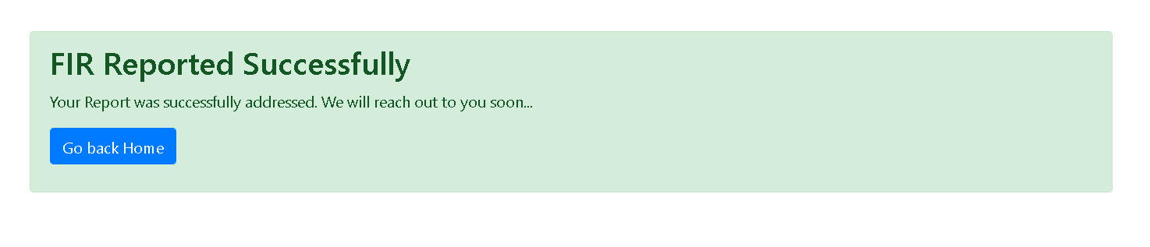

**FIR FILED SUCCESS JSP CODE:**

<%@ page language="java" contentType="text/html; charset=UTF-8" pageEncoding="UTF-8"%>

<!DOCTYPE html>

<html lang="en">

<head>

<meta charset="UTF-8">

<meta name="viewport" content="width=device-width, initial-scale=1.0">

<title>FIR REPORTED SUCCESSFULLY</title>

<link rel="stylesheet" href="https://maxcdn.bootstrapcdn.com/bootstrap/4.5.2/css/bootstrap.min.css">

</head>

<body>

<div class="container mt-5">

<div class="alert alert-success">

<h2>FIR Reported Successfully</h2>

<p>Your Report was successfully addressed. We will reach out to you soon...</p>

<p><a href="after_login.jsp" class="btn btn-primary">Go back Home </a></p>

</div>

</div>

<script>

// Disable the browser's back button

history.pushState(null, null, location.href);

window.onpopstate = function () {

history.go(1);

};

</script>

</body>

</html>

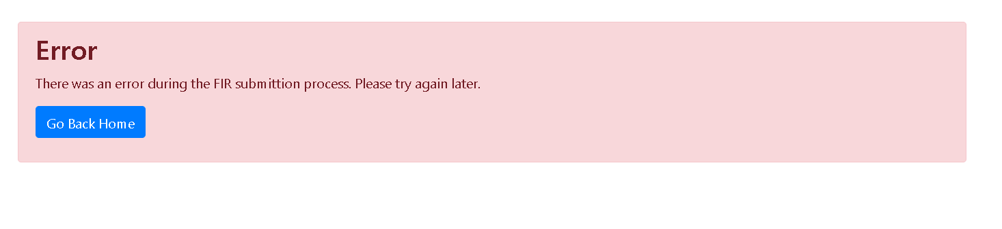

FIR FILED ERROR JSP CODE:-

<%@ page language="java" contentType="text/html; charset=UTF-8" pageEncoding="UTF-8"%>

<!DOCTYPE html>

<html lang="en">

<head>

<meta charset="UTF-8">

<meta name="viewport" content="width=device-width, initial-scale=1.0">

<title>FIR Submission Error</title>

<link rel="stylesheet" href="https://maxcdn.bootstrapcdn.com/bootstrap/4.5.2/css/bootstrap.min.css">

</head>

<body>

<div class="container mt-5">

<div class="alert alert-danger">

<h2>Error</h2>

<p>There was an error during the FIR submittion process. Please try again later.</p>

<p><a href="index.jsp" class="btn btn-primary">Go Back Home</a></p>

</div>

</div>

<script>

// Disable the browser's back button

history.pushState(null, null, location.href);

window.onpopstate = function () {

history.go(1);

};

</script>

</body>

</html>

**USER LOGOUT SERVLET:-**

package com.ecrh.backend;

import java.io.IOException;

import javax.servlet.ServletException;

import javax.servlet.annotation.WebServlet;

import javax.servlet.http.HttpServlet;

import javax.servlet.http.HttpServletRequest;

import javax.servlet.http.HttpServletResponse;

import javax.servlet.http.HttpSession;

@WebServlet("/LogoutServlet")

public class LogoutServlet extends HttpServlet {

protected void doPost(HttpServletRequest request, HttpServletResponse response)

throws ServletException, IOException {

HttpSession session = request.getSession();

// Invalidate the session to clear all session attributes

session.invalidate();

// Redirect to the index.jsp page or any other desired page

response.sendRedirect("index.jsp");

}

protected void doGet(HttpServletRequest request, HttpServletResponse response)

throws ServletException, IOException {

doPost(request, response);

}

}

**ADMIN PANEL LOGIN PAGE :-**

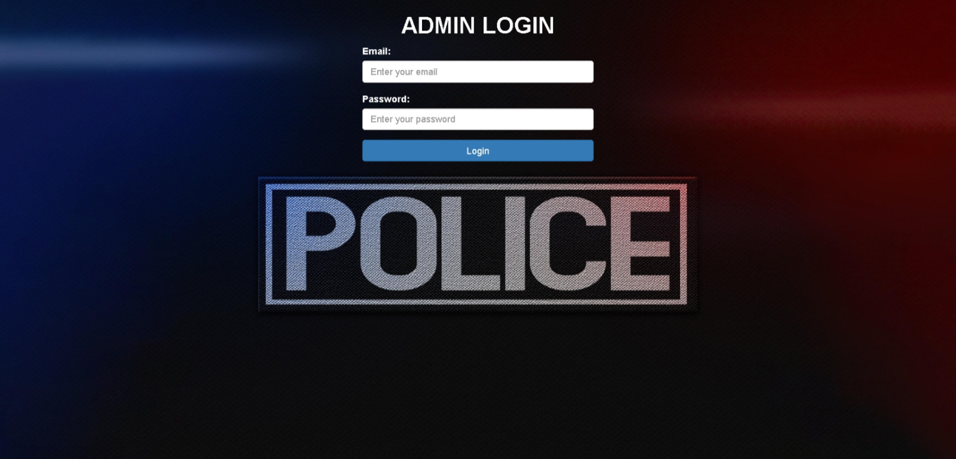

ADMIN PANEL LOGIN PAGE JSP CODE:-

<%@ page language="java" contentType="text/html; charset=ISO-8859-1"

pageEncoding="ISO-8859-1"%>

<!DOCTYPE html>

<html lang="en">

<head>

<title>Login Page</title>

<meta charset="utf-8">

<meta name="viewport" content="width=device-width, initial-scale=1">

<link rel="stylesheet" href="https://maxcdn.bootstrapcdn.com/bootstrap/3.4.1/css/bootstrap.min.css">

<script src="https://ajax.googleapis.com/libs/jquery/3.6.4/jquery.min.js"></script>

<script src="https://maxcdn.bootstrapcdn.com/bootstrap/3.4.1/js/bootstrap.min.js"></script>

</head>

<style>

body {

font-family: Arial, sans-serif;

margin: 0;

padding: 0;

background-size: cover;

background-image: url('images/9.jpg');

background-repeat: no-repeat;

background-attachment: fixed;

background-position: center center;

background-color: rgba(9, 118, 165, 0.7);

}

label{

color: white;}

</style>

<body>

<div class="container">

<div class="row">

<div class="col-xs-12 col-sm-6 col-sm-offset-3 col-md-4 col-md-offset-4">

<h1 style="text-align: center; font-weight: bold; color: white;">ADMIN LOGIN</h1>

<form action="AdminLogin" method="post">

<div class="form-group">

<label for="email">Email:</label>

<input type="email" class="form-control" id="email" name="email" placeholder="Enter your email"

required>

</div>

<div class="form-group">

<label for="password">Password:</label>

<input type="password" class="form-control" id="password" name="password"

placeholder="Enter your password" required>

</div>

<button type="submit" class="btn btn-primary btn-block">Login</button>

</form>

<!-- Display error message if it exists -->

<% String errorMessage = (String) request.getAttribute("errorMessage"); %>

<% if (errorMessage != null) { %>

<div class="alert alert-danger" role="alert" style="margin-top: 10px;">

<strong>Error:</strong> <%= errorMessage %>

</div>

<% } %>

</div>

</div>

</div>

<script>

// Clear any existing session

if (sessionStorage) {

sessionStorage.clear();

}

// Disable the browser's back button

history.pushState(null, null, location.href);

window.onpopstate = function () {

history.go(1);

};

</script>

</body>

</html>

**ADMIN PANEL HOMEPAGE :-**

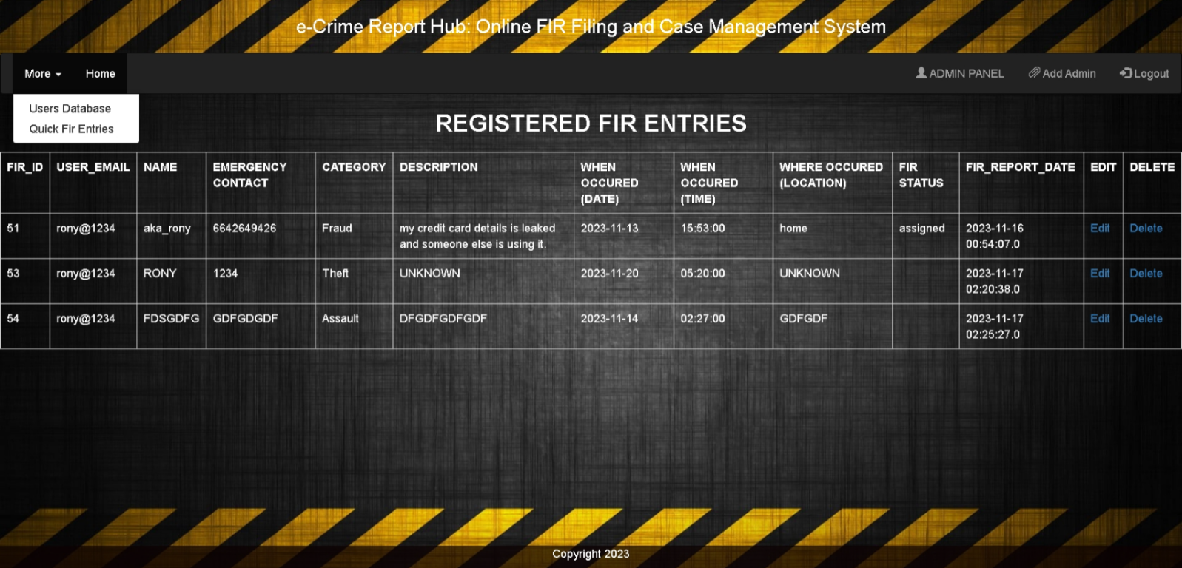

JSP CODE:-

<%@ page contentType="text/html; charset=UTF-8" %>

<%@ taglib uri="http://java.sun.com/jsp/jstl/core" prefix="c" %>

<%@ taglib uri="http://java.sun.com/jsp/jstl/sql" prefix="sql" %>

<%@ page import="java.sql.*" %>

<!DOCTYPE html>

<html>

<head>

<title>E-Crime Report Hub / My Complaints</title>

<meta charset="utf-8">

<meta name="viewport" content="width=device-width, initial-scale=1">

<link rel="stylesheet" href="https://maxcdn.bootstrapcdn.com/bootstrap/3.4.1/css/bootstrap.min.css">

<script src="https://ajax.googleapis.com/ajax/libs/jquery/3.6.4/jquery.min.js"></script>

<script src="https://maxcdn.bootstrapcdn.com/bootstrap/3.4.1/js/bootstrap.min.js"></script>

<style>

/* Custom CSS for the body */

body {

font-family: Arial, sans-serif;

margin: 0;

padding: 0;

background-image: url('images/17.jpg');

/* Replace 'your-image-url.jpg' with your image URL */

background-size: cover;

background-repeat: no-repeat;

background-attachment: fixed;

background-position: center center;

background-color: rgba(9, 118, 165, 0.7);

/* Background color with transparency */

}

/* Custom CSS for the "Emergency" container */

.emergency {

position: absolute;

bottom: 1px;

right: 10px;

width: 400px;

margin-bottom: 50px;

border: 1px solid #070000;

padding: 10px;

background-color: rgba(249, 249, 249, 0.7);

/* Adjusted background color with transparency */

border-radius: 10px;

}

@media (max-width: 767px) {

/* Media query for screens smaller than 768px (phones) */

.emergency {

position: static;

/* Remove absolute positioning */

margin: 20px auto;

/* Center the container horizontally */

width: 90%;

/* Adjust the width for smaller screens */

}

}

.footer {

position: fixed;

left: 0;

bottom: 0;

width: 100%;

background-color: rgba(13, 2, 2, 0.7);

color: white;

text-align: center;

}

/* Style for the complaint section */

.complaint {

border: 1px solid #ccc;

padding: 10px;

margin-bottom: 20px;

background-color: rgba(255, 255, 255, 0.8);

border-radius: 10px;

}

.complaint h3 {

margin-top: 0;

}

.status {

font-weight: bold;

}

/* Additional styles for different status */

.status-solved {

color: green;

}

.status-pending {

color: orange;

}

.status-processing {

color: blue;

}

.table td {

color: white;

}

.b1 {

font-weight: bold;

color: black;

}

</style>

<h3 style="text-align: center; margin-bottom: 20px; color: white;">e-Crime Report Hub: Online FIR Filing and Case

Management System

</h3>

</head>

<body>

<nav class="navbar navbar-inverse">

<div class="container-fluid">

<ul class="nav navbar-nav">

<li class="dropdown"><a class="dropdown-toggle" data-toggle="dropdown" href="#">More <span

class="caret"></span></a>

<ul class="dropdown-menu">

<li><a href="admin_usersdb.jsp">Users Database</a></li>

<li><a href="admin_QFE.jsp">Quick Fir Entries</a></li>

</ul>

</li>

<li class="active"><a href="admin_homepage.jsp">Home</a></li>

<!-- <li><a href="about_us.jsp">About Us</a></li> -->

</ul>

<ul class="nav navbar-nav navbar-right">

<li><a href="#"><span class="glyphicon glyphicon-user"></span> ADMIN PANEL</a></li>

<!-- <li><a href="#"><span class="glyphicon glyphicon-user"></span> ${session_username}</a></li> -->

<li><a href="add_admin.jsp"><span class="glyphicon glyphicon-paperclip"></span> Add Admin</a></li>

<li><a href="AdminLogoutServlet"><span class="glyphicon glyphicon-log-in"></span> Logout</a></li>

</ul>

</div>

</nav>

<h2 style="text-align: center; margin-bottom: 20px; color: white;font-weight:bold;">REGISTERED FIR ENTRIES </h3>

<sql:setDataSource

var="ds"

driver="com.mysql.jdbc.Driver"

url="jdbc:mysql://localhost:3306/ecrh"

user="root"

password="rony"

/>

<c:set var="userEmail" value="${sessionScope.user_email}" />

<sql:query dataSource="${ds}" var="rs">

SELECT fir_id , user_email , name , emergency_contact , category , description ,when_occured_date ,when_occurred_time ,where_occured_location ,FIR_status ,FIR_REPORT_DATE

FROM after_login_fir;

</sql:query>

<div class="table-responsive">

<table class="table table-bordered">

<tr class="b1">

<td>FIR_ID</td>

<td>USER_EMAIL</td>

<td>NAME</td>

<td>EMERGENCY CONTACT</td>

<td>CATEGORY</td>

<td>DESCRIPTION</td>

<td>WHEN OCCURED (DATE)</td>

<td>WHEN OCCURED (TIME)</td>

<td>WHERE OCCURED (LOCATION)</td>

<td>FIR STATUS</td>

<td> FIR_REPORT_DATE </td>

<td> EDIT</td>

<td> DELETE</td>

</tr>

<c:forEach var="row" items="${rs.rows}">

<tr>

<td><c:out value="${row.fir_id}"/></td>

<td><c:out value="${row.user_email}"/></td>

<td><c:out value="${row.name}"/></td>

<td><c:out value="${row.emergency_contact}"/></td>

<td><c:out value="${row.category}"/></td>

<td><c:out value="${row.description}"/></td>

<td><c:out value="${row.when_occured_date}"/></td>

<td><c:out value="${row.when_occurred_time}"/></td>

<td><c:out value="${row.where_occured_location}"/></td>

<td><c:out value="${row.FIR_status}"/></td>

<td><c:out value="${row.FIR_REPORT_DATE}"/></td>

<td><a href="admin_edit_fir.jsp?id=${row.fir_id}">Edit</a></td>

<td><a href="admin_delete_fir.jsp?id=${row.fir_id}">Delete</a></td>

</tr>

</c:forEach>

</table>

</div>

<div class="footer">

<p>Copyright 2023</p>

</div>

<script>

// Disable the browser's back button

history.pushState(null, null, location.href);

window.onpopstate = function () {

history.go(1);

};

</script>

</body>

</html>

**ADMIN EDIT USERS_db PAGE :-**

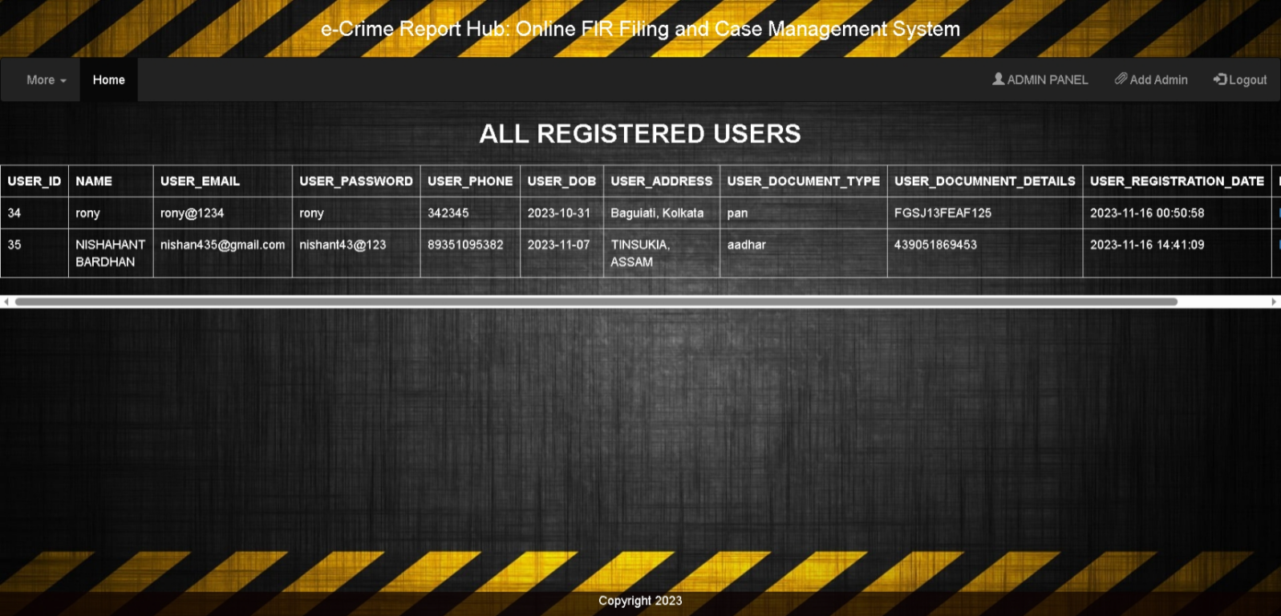

Jsp code:-

<%@ page contentType="text/html; charset=UTF-8" %>

<%@ taglib uri="http://java.sun.com/jsp/jstl/core" prefix="c" %>

<%@ taglib uri="http://java.sun.com/jsp/jstl/sql" prefix="sql" %>

<%@ page import="java.sql.*" %>

<!DOCTYPE html>

<html>

<head>

<meta charset="UTF-8">

<meta name="viewport" content="width=device-width, initial-scale=1">

<title>Edit Users Data </title>

<link rel="stylesheet" href="https://maxcdn.bootstrapcdn.com/bootstrap/3.4.1/css/bootstrap.min.css">

<style>

body {

font-family: Arial, sans-serif;

background-color: #f2f2f2;

}

.container {

max-width: 800px;

margin: 0 auto;

margin-top: 50px;

padding: 20px;

background-color: #fff;

border: 1px solid #ddd;

border-radius: 5px;

}

h2 {

text-align: center;

}

.form-group {

margin-bottom: 20px;

}

.btn-update {

background-color: #337ab7;

color: #fff;

}

</style>

</head>

<body>

<div class="container">

<h2>Edit User's Data</h2>

<c:if test="${not empty param.id}">

<sql:setDataSource

var="ds"

driver="com.mysql.jdbc.Driver"

url="jdbc:mysql://localhost:3306/ecrh"

user="root"

password="rony"

/>

<c:set var="firId" value="${param.id}" />

<sql:query dataSource="${ds}" var="firData">

SELECT name, email, password, phone, dob, address, document_type, document_details

FROM users

WHERE user_id = ${param.id}

</sql:query>

<form action="AdminEditUserData" method="post">

<div class="form-group">

<label for="userId">User ID:</label>

<input type="text" class="form-control" id="userId" name="userId" required placeholder="User ID" value="${param.id}" required readonly>

</div>

<c:forEach var="row" items="${firData.rows}">

<div class="form-group">

<label for="name">Name:</label>

<input type="text" class="form-control" id="name" name="name" required placeholder="User Name" value="${row.name}" required>

</div>

<div class="form-group">

<label for="email">Email:</label>

<input type="text" class "form-control" id="email" name="email" required placeholder="User Email" value="${row.email}" required>

</div>

<div class="form-group">

<label for="password">Password:</label>

<input type="text" class="form-control" id="password" name="password" required placeholder="Password" value="${row.password}" required>

</div>

<div class="form-group">

<label for="phone">Phone:</label>

<input type="text" class="form-control" id="phone" name="phone" placeholder="Phone Number" value="${row.phone}" required>

</div>

<div class="form-group">

<label for="dob">Date of Birth:</label>

<input type="date" class="form-control" id="dob" name="dob" placeholder="Date of Birth" value="${row.dob}"required>

</div>

<div class="form-group">

<label for="address">Address:</label>

<input type="text" class="form-control" id="address" name="address" placeholder="Address" value="${row.address}"required>

</div>

<div class="form-group">

<label for="documentType">Document Type:</label>

<input type="text" class="form-control" id="documentType" name="documentType" placeholder="Document Type" value="${row.document_type}"required>

</div>

<div class="form-group">

<label for="documentDetails">Document Details:</label>

<input type="text" class="form-control" id="documentDetails" name="documentDetails" placeholder="Document Details" value="${row.document_details}"required>

</div>

</c:forEach>

<button type="submit" class="btn btn-primary btn-update">Update</button>

</form>

</c:if>

</div>

</body>

</html>

**ADMIN EDIT QUICK_FIR_db PAGE :-**

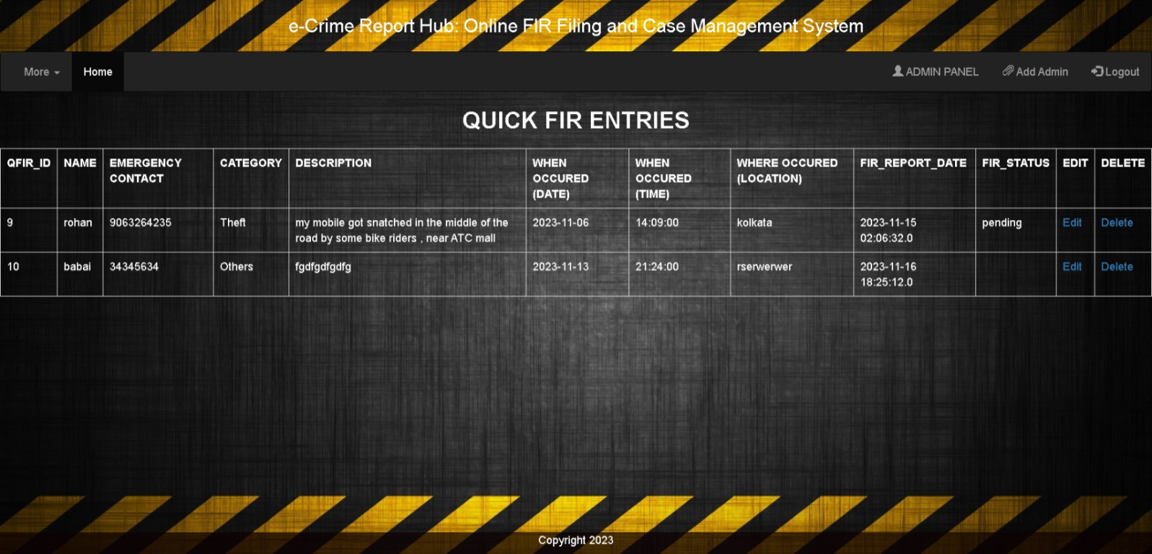

Jsp code:-

<%@ page contentType="text/html; charset=UTF-8" %>

<%@ taglib uri="http://java.sun.com/jsp/jstl/core" prefix="c" %>

<%@ taglib uri="http://java.sun.com/jsp/jstl/sql" prefix="sql" %>

<%@ page import="java.sql.*" %>

<!DOCTYPE html>

<html>

<head>

<title>E-Crime Report Hub / My Complaints</title>

<meta charset="utf-8">

<meta name="viewport" content="width=device-width, initial-scale=1">

<link rel="stylesheet" href="https://maxcdn.bootstrapcdn.com/bootstrap/3.4.1/css/bootstrap.min.css">

<script src="https://ajax.googleapis.com/ajax/libs/jquery/3.6.4/jquery.min.js"></script>

<script src="https://maxcdn.bootstrapcdn.com/bootstrap/3.4.1/js/bootstrap.min.js"></script>

<style>

/* Custom CSS for the body */

body {

font-family: Arial, sans-serif;

margin: 0;

padding: 0;

background-image: url('images/17.jpg');

/* Replace 'your-image-url.jpg' with your image URL */

background-size: cover;

background-repeat: no-repeat;

background-attachment: fixed;

background-position: center center;

background-color: rgba(9, 118, 165, 0.7);

/* Background color with transparency */

}

/* Custom CSS for the "Emergency" container */

.emergency {

position: absolute;

bottom: 1px;

right: 10px;

width: 400px;

margin-bottom: 50px;

border: 1px solid #070000;

padding: 10px;

background-color: rgba(249, 249, 249, 0.7);

/* Adjusted background color with transparency */

border-radius: 10px;

}

@media (max-width: 767px) {

/* Media query for screens smaller than 768px (phones) */

.emergency {

position: static;

/* Remove absolute positioning */

margin: 20px auto;

/* Center the container horizontally */

width: 90%;

/* Adjust the width for smaller screens */

}

}

.footer {

position: fixed;

left: 0;

bottom: 0;

width: 100%;

background-color: rgba(13, 2, 2, 0.7);

color: white;

text-align: center;

}

/* Style for the complaint section */

.complaint {

border: 1px solid #ccc;

padding: 10px;

margin-bottom: 20px;

background-color: rgba(255, 255, 255, 0.8);

border-radius: 10px;

}

.complaint h3 {

margin-top: 0;

}

.status {

font-weight: bold;

}

/* Additional styles for different status */

.status-solved {

color: green;

}

.status-pending {

color: orange;

}

.status-processing {

color: blue;

}

.table td {

color: white;

}

.b1 {

font-weight: bold;

color: black;

}

</style>

<h3 style="text-align: center; margin-bottom: 20px; color: white;">e-Crime Report Hub: Online FIR Filing and Case

Management System

</h3>

</head>

<body>

<nav class="navbar navbar-inverse">

<div class="container-fluid">

<ul class="nav navbar-nav">

<li class="dropdown"><a class="dropdown-toggle" data-toggle="dropdown" href="#">More <span

class="caret"></span></a>

<ul class="dropdown-menu">

<li><a href="admin_usersdb.jsp">Users Database</a></li>

<li><a href="admin_QFE.jsp">Quick Fir Entries</a>

</li>

<li class="active"><a href="admin_homepage.jsp">Home</a></li>

<!-- <li><a href="about_us.jsp">About Us</a></li> -->

</ul>

<ul class="nav navbar-nav navbar-right">

<!-- <li><a href="#"><span class="glyphicon glyphicon-user"></span> ${session_username }</a></li> -->

<li><a href="#"><span class="glyphicon glyphicon-user"></span> ADMIN PANEL</a></li>

<li><a href="add_admin.jsp"><span class="glyphicon glyphicon-paperclip"></span> Add Admin</a></li>

<li><a href="AdminLogoutServlet"><span class="glyphicon glyphicon-log-in"></span> Logout</a></li>

</ul>

</div>

</nav>

<h2 style="text-align: center; margin-bottom: 20px; color: white;font-weight:bold;"> QUICK FIR ENTRIES </h3>

<sql:setDataSource

var="ds"

driver="com.mysql.jdbc.Driver"

url="jdbc:mysql://localhost:3306/ecrh"

user="root"

password="rony"

/>

<c:set var="userEmail" value="${sessionScope.user_email}" />

<sql:query dataSource="${ds}" var="rs">

SELECT fir_id , name ,

emergency_contact , category , description ,

when_occured_date , when_occurred_time , where_occured_location ,

FIR_REPORT_DATE,FIR_STATUS

FROM quick_fir_reports;

<div class="table-responsive">

<table class="table table-bordered">

<tr class="b1">

<td>QFIR_ID</td>

<td>NAME</td>

<td>EMERGENCY CONTACT</td>

<td>CATEGORY</td>

<td>DESCRIPTION</td>

<td>WHEN OCCURED (DATE)</td>

<td>WHEN OCCURED (TIME)</td>

<td>WHERE OCCURED (LOCATION)</td>

<td> FIR_REPORT_DATE </td>

<td> FIR_STATUS </td>

<td> EDIT</td>

<td> DELETE</td>

</tr>

<c:forEach var="row" items="${rs.rows}">

<tr>

<td><c:out value="${row.fir_id}"/></td>

<td><c:out value="${row.name}"/></td>

<td><c:out value="${row.emergency_contact}"/></td>

<td><c:out value="${row.category}"/></td>

<td><c:out value="${row.description}"/></td>

<td><c:out value="${row.when_occured_date}"/></td>

<td><c:out value="${row.when_occurred_time}"/></td>

<td><c:out value="${row.where_occured_location}"/></td>

<td><c:out value="${row.FIR_REPORT_DATE}"/></td>

<td><c:out value="${row.FIR_STATUS}"/></td>

<td><a href="admin_edit_qfir.jsp?id=${row.fir_id}">Edit</a></td>

<td><a href="admin_delete_qfir.jsp?id=${row.fir_id}">Delete</a></td>

</tr>

</c:forEach>

</table>

</div>

<div class="footer">

<p>Copyright 2023</p>

</div>

</body>

</html>

**ADD ADMIN PAGE :-**

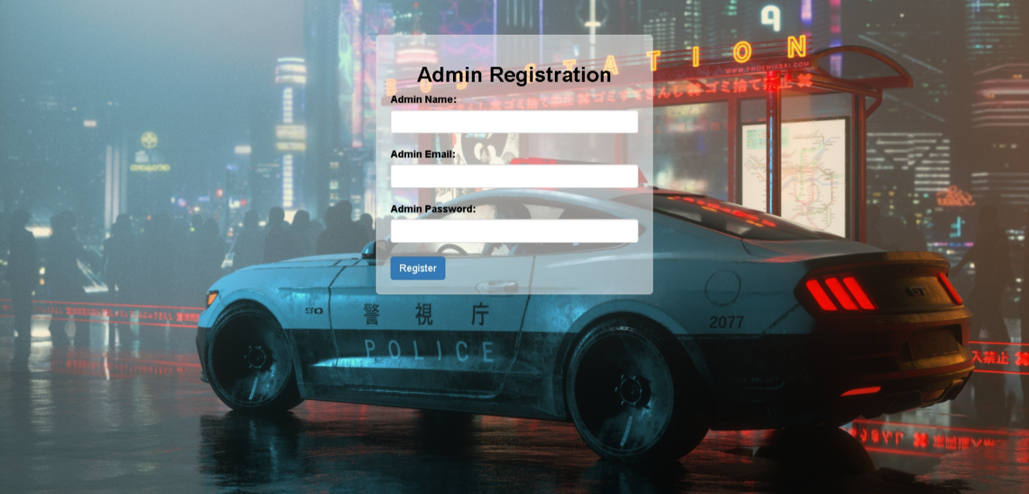

Jsp code:-

<%@ page contentType="text/html; charset=UTF-8" %>

<!DOCTYPE html>

<html>

<head>

<meta charset="UTF-8">

<meta name="viewport" content="width=device-width, initial-scale=1">

<title>Admin Registration</title>

<link rel="stylesheet" href="https://maxcdn.bootstrapcdn.com/bootstrap/3.4.1/css/bootstrap.min.css">

<style>

body {

font-family: Arial, sans-serif;

margin: 0;

padding: 0;

background-image: url('images/10.jpg');

/* Replace 'your-image-url.jpg' with your image URL */

background-size: cover;

background-repeat: no-repeat;

background-attachment: fixed;

background-position: center center;

background-color: rgba(255, 255, 255, 0.3);

/* Background color with transparency */

}

.container {

max-width: 400px;

margin: 0 auto;

margin-top: 50px;

padding: 20px;

/* background-color: #fff; */

background-color: rgba(255, 255, 255, 0.5);

border: 1px solid #ddd;

border-radius: 5px;

}

h2 {

text-align: center;

}

.form-group {

margin-bottom: 20px;

}

.btn-register {

background-color: #337ab7;

color: #fff;

}

label{

color: black;}

</style>

</head>

<body>

<div class="container">

<h2 style= color:black;font-weight:bold;>Admin Registration</h2>

<form action="AddAdmin" method="post">

<div class="form-group">

<label for="adminName">Admin Name:</label>

<input type="text" class="form-control" id="adminName" name="adminName" required>

</div>

<div class="form-group">

<label for="adminEmail">Admin Email:</label>

<input type="email" class="form-control" id="adminEmail" name="adminEmail" required>

</div>

<div class="form-group">

<label for="adminPass">Admin Password:</label>

<input type="password" class="form-control" id="adminPass" name="adminPass" required>

</div>

<button type="submit" class="btn btn-primary btn-register">Register</button>

</form>

</div>

<script>

function validateForm() {

var emailInput = document.getElementById("email");

var emailError = document.getElementById("emailError");

var email = emailInput.value;

if (email.indexOf("@") === -1) {

emailError.textContent = "Please enter a valid email address.";

emailInput.focus();

return false;

}

return true;

}

function showDocumentDetails() {

var documentSelect = document.getElementById("document");

var documentDetails = document.getElementById("documentDetails");

var documentDetailsInput = document.getElementById("documentDetailsInput");

if (documentSelect.value !== "select") {

documentDetails.style.display = "block";

documentDetailsInput.setAttribute("required", "true");

// Set the placeholder based on the selected option

var selectedOption = documentSelect.options[documentSelect.selectedIndex].text;

documentDetailsInput.placeholder = "Enter " + selectedOption + " details";

} else {

documentDetails.style.display = "none";

documentDetailsInput.removeAttribute("required");

}

}

</script>

</body>

</html>

**ADD ADMIN SERVLET CODE:-**

package com.ecrh.backend;

import java.io.IOException;

import java.io.PrintWriter;

import java.sql.Connection;

import java.sql.DriverManager;

import java.sql.PreparedStatement;

import java.sql.SQLException;

import javax.servlet.RequestDispatcher;

import javax.servlet.ServletException;

import javax.servlet.annotation.WebServlet;

import javax.servlet.http.HttpServlet;

import javax.servlet.http.HttpServletRequest;

import javax.servlet.http.HttpServletResponse;

@WebServlet("/AddAdmin")

public class AddAdmin extends HttpServlet {

private static final long serialVersionUID = 1L;

public AddAdmin() {

}

protected void doPost(HttpServletRequest request, HttpServletResponse response)

throws ServletException, IOException {

PrintWriter out = response.getWriter();

String myname = request.getParameter("adminName"); // Updated parameter name

String myemail = request.getParameter("adminEmail"); // Updated parameter name

String mypass = request.getParameter("adminPass"); // Updated parameter name

try {

Class.forName("com.mysql.cj.jdbc.Driver");

Connection con = DriverManager.getConnection("jdbc:mysql://localhost:3306/ecrh", "root", "rony");

PreparedStatement ps = con.prepareStatement(

"INSERT INTO admins (admin_name, email, password) VALUES (?, ?, ?)",

PreparedStatement.RETURN_GENERATED_KEYS);

ps.setString(1, myname);

ps.setString(2, myemail);

ps.setString(3, mypass);

int count = ps.executeUpdate();

if (count > 0) {

// Registration was successful, so retrieve the auto-generated admin_id

java.sql.ResultSet generatedKeys = ps.getGeneratedKeys();

if (generatedKeys.next()) {

int generatedId = generatedKeys.getInt(1);

response.setContentType("text/html");

out.print("<h3>Admin registered successfully with ID: " + generatedId + "</h3>");

}

RequestDispatcher rd = request.getRequestDispatcher("/admin_added_success.jsp");

rd.forward(request, response);

} else {

// Registration was not successful, do not display admin_id

RequestDispatcher rd = request.getRequestDispatcher("/admin_added_failed.jsp");

rd.forward(request, response);

}

} catch (SQLException | ClassNotFoundException e) {

e.printStackTrace();

response.setContentType("text/html");

out.print("<h3>Exception Occurred: " + e.getMessage() + " </h3>");

RequestDispatcher rd = request.getRequestDispatcher("/admin_added_failed.jsp");

rd.forward(request, response);

}

}

}

**ADMIN DELETE FIR SERVLET:-**

package com.ecrh.backend;

import java.io.IOException;

import java.sql.Connection;

import java.sql.DriverManager;

import java.sql.PreparedStatement;

import java.sql.SQLException;

import javax.servlet.ServletException;

import javax.servlet.annotation.WebServlet;

import javax.servlet.http.HttpServlet;

import javax.servlet.http.HttpServletRequest;

import javax.servlet.http.HttpServletResponse;

@WebServlet("/AdminDeleteFIRRecords")

public class AdminDeleteFIRRecords extends HttpServlet {

private static final long serialVersionUID = 1L;

public AdminDeleteFIRRecords() {

super();

}

protected void doPost(HttpServletRequest request, HttpServletResponse response)

throws ServletException, IOException {

String firId = request.getParameter("firId");

try {

Class.forName("com.mysql.cj.jdbc.Driver");

Connection con = DriverManager.getConnection("jdbc:mysql://localhost:3306/ecrh", "root", "rony");

String deleteQuery = "DELETE FROM after_login_FIR WHERE fir_id = ?";

PreparedStatement ps = con.prepareStatement(deleteQuery);

ps.setString(1, firId);

int count = ps.executeUpdate();

if (count > 0) {

// Deletion successful

response.sendRedirect("FIR_DELETED_SUCCESS.jsp");

} else {

// Deletion failed

response.sendRedirect("FIR_DELETED_FAILED.jsp");

}

con.close();

} catch (ClassNotFoundException | SQLException e) {

e.printStackTrace();

response.sendRedirect("FIR_DELETED_FAILED.jsp");

}

}

}

**ADMIN DELETE QUICK_FIR SERVLET:-**

package com.ecrh.backend;

import java.io.IOException;

import java.sql.Connection;

import java.sql.DriverManager;

import java.sql.PreparedStatement;

import java.sql.SQLException;

import javax.servlet.ServletException;

import javax.servlet.annotation.WebServlet;

import javax.servlet.http.HttpServlet;

import javax.servlet.http.HttpServletRequest;

import javax.servlet.http.HttpServletResponse;

@WebServlet("/AdminDeleteQFIRRecords")

public class AdminDeleteQFIRRecords extends HttpServlet {

private static final long serialVersionUID = 1L;

public AdminDeleteQFIRRecords() {

super();

}

protected void doPost(HttpServletRequest request, HttpServletResponse response)

throws ServletException, IOException {

String firId = request.getParameter("firId");

try {

Class.forName("com.mysql.cj.jdbc.Driver");

Connection con = DriverManager.getConnection("jdbc:mysql://localhost:3306/ecrh", "root", "rony");

String deleteQuery = "DELETE FROM quick_fir_reports WHERE fir_id = ?";

PreparedStatement ps = con.prepareStatement(deleteQuery);

ps.setString(1, firId);

int count = ps.executeUpdate();

if (count > 0) {

// Deletion successful

response.sendRedirect("FIR_DELETED_SUCCESS.jsp");

} else {

// Deletion failed

response.sendRedirect("FIR_DELETED_FAILED.jsp");

}

con.close();

} catch (ClassNotFoundException | SQLException e) {

e.printStackTrace();

response.sendRedirect("FIR_DELETED_FAILED.jsp");

}

}

}

**ADMIN DELETE USERS SERVLET:-**

package com.ecrh.backend;

import java.io.IOException;

import java.sql.Connection;

import java.sql.DriverManager;

import java.sql.PreparedStatement;

import java.sql.SQLException;

import javax.servlet.ServletException;

import javax.servlet.annotation.WebServlet;

import javax.servlet.http.HttpServlet;

import javax.servlet.http.HttpServletRequest;

import javax.servlet.http.HttpServletResponse;

@WebServlet("/AdminDeleteUsers")

public class AdminDeleteUsers extends HttpServlet {

private static final long serialVersionUID = 1L;

public AdminDeleteUsers() {

super();

}

protected void doPost(HttpServletRequest request, HttpServletResponse response)

throws ServletException, IOException {

String userId = request.getParameter("userId");

try {

Class.forName("com.mysql.cj.jdbc.Driver");

Connection con = DriverManager.getConnection("jdbc:mysql://localhost:3306/ecrh", "root", "rony");

String deleteQuery = "DELETE FROM users WHERE user_id = ?";

PreparedStatement ps = con.prepareStatement(deleteQuery);

ps.setString(1, userId);

int count = ps.executeUpdate();

if (count > 0) {

// Deletion successful

response.sendRedirect("USER_DELETED_SUCCESS.jsp");

} else {

// Deletion failed

response.sendRedirect("USER_DELETED_FAILED.jsp");

}

con.close();

} catch (ClassNotFoundException | SQLException e) {

e.printStackTrace();

response.sendRedirect("USER_DELETED_FAILED.jsp");

}

}

}

**ADMIN EDIT USERS SERVLET:-**

package com.ecrh.backend;

import java.io.IOException;

import java.sql.Connection;

import java.sql.DriverManager;

import java.sql.PreparedStatement;

import java.sql.SQLException;

import javax.servlet.ServletException;

import javax.servlet.annotation.WebServlet;

import javax.servlet.http.HttpServlet;

import javax.servlet.http.HttpServletRequest;

import javax.servlet.http.HttpServletResponse;

import javax.servlet.http.HttpSession;

@WebServlet("/AdminEditUserData")

public class AdminEditUserData extends HttpServlet {

private static final long serialVersionUID = 1L;

public AdminEditUserData() {

super();

}

protected void doPost(HttpServletRequest request, HttpServletResponse response)

throws ServletException, IOException {

String userId = request.getParameter("userId");

String name = request.getParameter("name");

String email = request.getParameter("email");

String password = request.getParameter("password");

String phone = request.getParameter("phone");

String dob = request.getParameter("dob");

String address = request.getParameter("address");

String documentType = request.getParameter("documentType");

String documentDetails = request.getParameter("documentDetails");

try {

Class.forName("com.mysql.cj.jdbc.Driver");

Connection con = DriverManager.getConnection("jdbc:mysql://localhost:3306/ecrh", "root", "rony");

String updateQuery = "UPDATE users SET name=?, email=?, password=?, phone=?, dob=?, address=?, document_type=?, document_details=? WHERE user_id=?";

PreparedStatement ps = con.prepareStatement(updateQuery);

ps.setString(1, name);

ps.setString(2, email);

ps.setString(3, password);

ps.setString(4, phone);

ps.setString(5, dob);

ps.setString(6, address);

ps.setString(7, documentType);

ps.setString(8, documentDetails);

ps.setString(9, userId);

int count = ps.executeUpdate();

if (count > 0) {

// Update successful

HttpSession session = request.getSession();

session.removeAttribute(userId); // Clear session attribute for this FIR ID

response.sendRedirect("user_update_success.jsp");

} else {

// Update failed

response.sendRedirect("user_update_failed.jsp");

}

con.close();

} catch (ClassNotFoundException | SQLException e) {

e.printStackTrace();

response.sendRedirect("user_update_failed.jsp");

}

}

}

**ADMIN EDIT QUICK_FIR SERVLET:-**

package com.ecrh.backend;

import java.io.IOException;

import java.sql.Connection;

import java.sql.DriverManager;

import java.sql.PreparedStatement;

import java.sql.SQLException;

import javax.servlet.ServletException;

import javax.servlet.annotation.WebServlet;

import javax.servlet.http.HttpServlet;

import javax.servlet.http.HttpServletRequest;

import javax.servlet.http.HttpServletResponse;

import javax.servlet.http.HttpSession;

@WebServlet("/AdminEditQFIRRecords")

public class AdminEditQFIRRecords extends HttpServlet {

private static final long serialVersionUID = 1L;

public AdminEditQFIRRecords() {

super();

}

protected void doPost(HttpServletRequest request, HttpServletResponse response)

throws ServletException, IOException {

String firId = request.getParameter("firId");

String name = request.getParameter("name");

String emergencyContact = request.getParameter("emergencyContact");

String category = request.getParameter("category");

String description = request.getParameter("description");

String whenOccurredDate = request.getParameter("whenOccurredDate");

String whenOccurredTime = request.getParameter("whenOccurredTime");

String whereOccurredLocation = request.getParameter("whereOccurredLocation");

String newFIRStatus = request.getParameter("newFIRStatus");

try {

Class.forName("com.mysql.cj.jdbc.Driver");

Connection con = DriverManager.getConnection("jdbc:mysql://localhost:3306/ecrh", "root", "rony");

String updateQuery = "UPDATE quick_fir_reports SET name=?, emergency_contact=?, category=?, description=?, when_occured_date=?, when_occurred_time=?, where_occured_location=?, FIR_status=? WHERE fir_id=?";

PreparedStatement ps = con.prepareStatement(updateQuery);

ps.setString(1, name);

ps.setString(2, emergencyContact);

ps.setString(3, category);

ps.setString(4, description);

ps.setString(5, whenOccurredDate);

ps.setString(6, whenOccurredTime);

ps.setString(7, whereOccurredLocation);

ps.setString(8, newFIRStatus);

ps.setString(9, firId);

int count = ps.executeUpdate();

if (count > 0) {

// Update successful

HttpSession session = request.getSession();

session.removeAttribute(firId); // Clear session attribute for this FIR ID

response.sendRedirect("fir_updated_success.jsp");

} else {

// Update failed

response.sendRedirect("fir_updated_failed.jsp");

}

con.close();

} catch (ClassNotFoundException | SQLException e) {

e.printStackTrace();

response.sendRedirect("fir_updated_failed.jsp");

}

}

}

**ADMIN EDIT FIR SERVLET:-**

package com.ecrh.backend;

import java.io.IOException;

import java.sql.Connection;

import java.sql.DriverManager;

import java.sql.PreparedStatement;

import java.sql.SQLException;

import javax.servlet.ServletException;

import javax.servlet.annotation.WebServlet;

import javax.servlet.http.HttpServlet;

import javax.servlet.http.HttpServletRequest;

import javax.servlet.http.HttpServletResponse;

import javax.servlet.http.HttpSession;

@WebServlet("/AdminEditNormalFIRRecords")

public class AdminEditNormalFIRRecords extends HttpServlet {

private static final long serialVersionUID = 1L;

public AdminEditNormalFIRRecords() {

super();

}

protected void doPost(HttpServletRequest request, HttpServletResponse response)

throws ServletException, IOException {

String firId = request.getParameter("firId");

String userEmail = request.getParameter("userEmail");

String name = request.getParameter("name");

String emergencyContact = request.getParameter("emergencyContact");

String category = request.getParameter("category");

String description = request.getParameter("description");

String whenOccurredDate = request.getParameter("whenOccurredDate");

String whenOccurredTime = request.getParameter("whenOccurredTime");

String whereOccurredLocation = request.getParameter("whereOccurredLocation");

String newFIRStatus = request.getParameter("newFIRStatus");

try {

Class.forName("com.mysql.cj.jdbc.Driver");

Connection con = DriverManager.getConnection("jdbc:mysql://localhost:3306/ecrh", "root", "rony");

String updateQuery = "UPDATE after_login_fir SET user_email=?, name=?, emergency_contact=?, category=?, description=?, when_occured_date=?, when_occurred_time=?, where_occured_location=?, FIR_status=? WHERE fir_id=?";

PreparedStatement ps = con.prepareStatement(updateQuery);

ps.setString(1, userEmail);

ps.setString(2, name);

ps.setString(3, emergencyContact);

ps.setString(4, category);

ps.setString(5, description);

ps.setString(6, whenOccurredDate);

ps.setString(7, whenOccurredTime);

ps.setString(8, whereOccurredLocation);

ps.setString(9, newFIRStatus);

ps.setString(10, firId);

int count = ps.executeUpdate();

if (count > 0) {

// Update successful

HttpSession session = request.getSession();

session.removeAttribute(firId); // Clear session attribute for this FIR ID

response.sendRedirect("fir_updated_success.jsp");

} else {

// Update failed

response.sendRedirect("fir_updated_failed.jsp");

}

con.close();

} catch (ClassNotFoundException | SQLException e) {

e.printStackTrace();

response.sendRedirect("fir_updated_failed.jsp");

}

}

}

# TESTING

# **Manual Testing**:

# **Definition**: Manual testing involves human intervention to execute test cases without the use of automation tools.

# **Significance**: It allows testers to explore the application, identify bugs, and evaluate the user interface from a user's perspective.

# **Process**: Testers execute test cases step by step, observing the system's behavior, and validating whether it aligns with the expected outcomes specified in the requirements.

# **Positive Testing:**

# **Definition**: Positive testing validates the system's behavior when provided with expected and valid input.

# **Scenario**: For our project, positive testing could involve entering valid user information during registration, filing an FIR with all required fields filled correctly, and checking if the system processes it without errors.

# **Negative Testing:**

# **Definition**: Negative testing evaluates the system's behavior when provided with unexpected or invalid input.

# **Scenario**: In our project, negative testing might include attempting to register with incomplete user details, filing an FIR with missing mandatory information, or entering incorrect data formats (e.g., entering letters in a numeric field).

# **Manual Testing in our Project:**

# **Scope**: As we performed manual testing, we manually executed test scenarios covering various functionalities like user registration, FIR filing, login functionality, and error handling.

# **Execution**: Describe how we interacted with the application step by step, providing different inputs and observing the system's responses.

# **Validation**: Explain how we validated each test scenario against the expected outcomes and whether the system behaved as intended.

# **Bug Reporting**: If we found any issues or discrepancies, detail how we reported them, including steps to reproduce the problem, its impact, and the expected versus actual behavior.

**Positive Testing with JavaScript Validation:**

Scenario: User registration form validation (positive testing), Delete FIR from admin panel , add new admin etc…

* JavaScript Code Functionality:
  + - Validate that all mandatory fields are filled out correctly (name, email, password, etc.)
    - Check email format validity using JavaScript regex.
    - Ensure passwords meet complexity requirements (length, special characters, etc.).

Observation: Document the behavior when valid inputs are entered:

* + - When all mandatory fields are correctly filled, the form submits successfully.
    - For instance, if a user enters a valid email format (e.g., "user@example.com"), the validation script allows the form submission.
    - If the admin wants to delete an FIR entry for the very first time it wont give any error, and if the admin tries to delete the same entry again it raises an exception.(discussed in later part).
    - If the admin is logged in and wants to add another admin , he/she can do that if they put the details correct format.

`

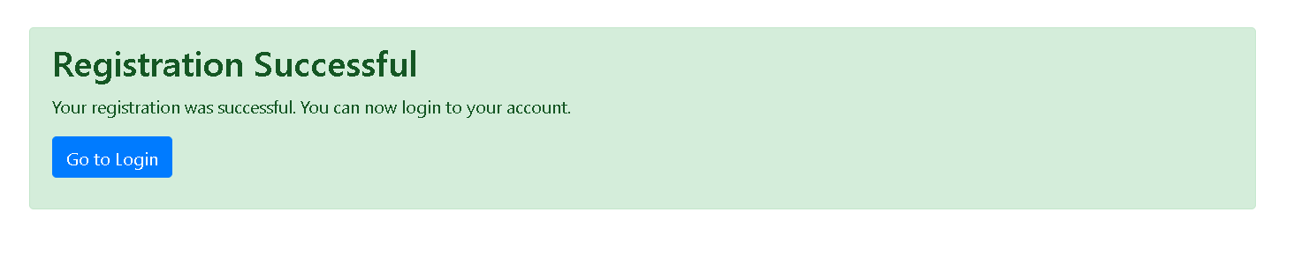

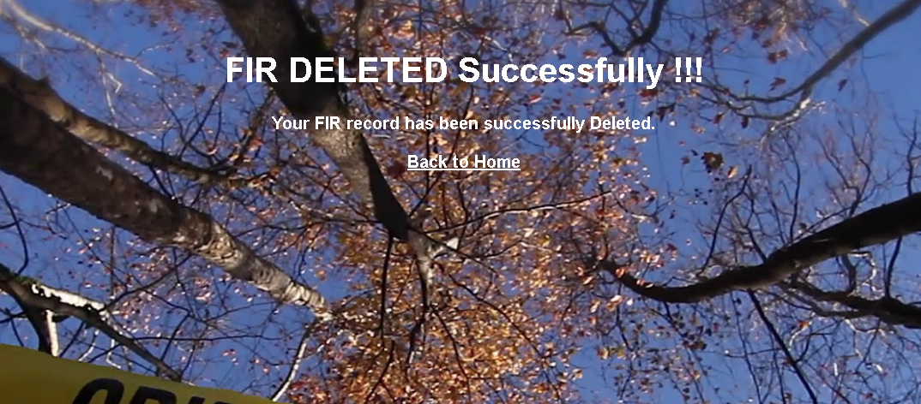

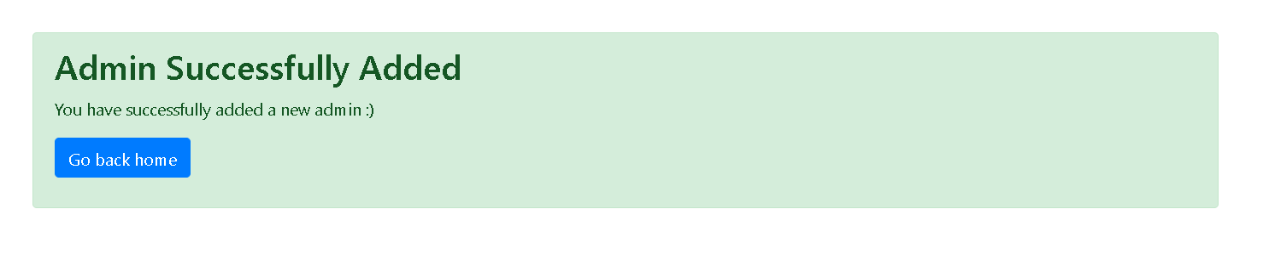

**Negative Testing with JavaScript Validation:**

Scenario: Invalid user inputs (negative testing)

* JavaScript Code Functionality:
  + - Trigger error messages for missing mandatory fields upon form submission.
    - Display error messages for incorrectly formatted email or passwords that don’t meet complexity requirements.

Observation: Document the behavior when invalid inputs are entered:

* If a user attempts to submit the form without filling in mandatory fields, JavaScript validation prevents form submission and prompts the user to fill in the required fields.
* For instance, if an invalid email format (e.g., "user.com") is entered, the validation script displays an error message requesting a valid email.

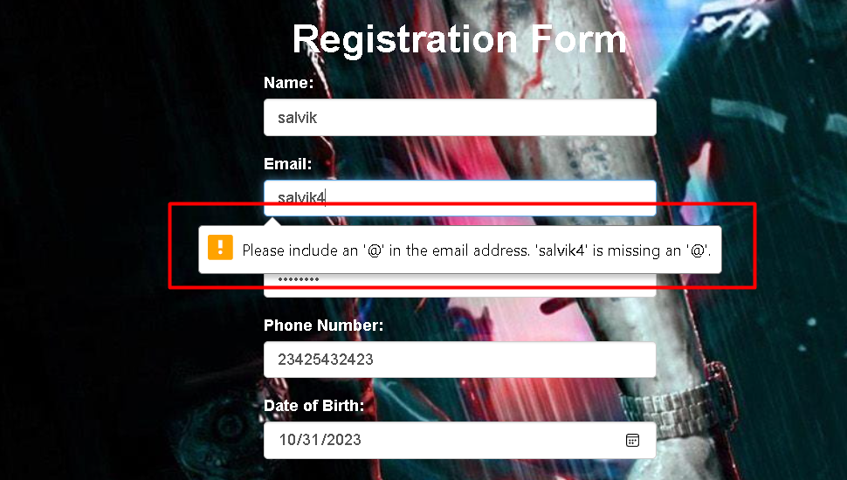

**Javascript code for validating email during registration:-**

<script>

function validateForm() {

var emailInput = document.getElementById("email");

var emailError = document.getElementById("emailError");

var email = emailInput.value;

if (email.indexOf("@") === -1) {

emailError.textContent = "Please enter a valid email address.";

emailInput.focus();

return false;

}

return true;

}

function showDocumentDetails() {

var documentSelect = document.getElementById("document");

var documentDetails = document.getElementById("documentDetails");

var documentDetailsInput = document.getElementById("documentDetailsInput");

if (documentSelect.value !== "select") {

documentDetails.style.display = "block";

documentDetailsInput.setAttribute("required", "true");

// Set the placeholder based on the selected option

var selectedOption = documentSelect.options[documentSelect.selectedIndex].text;

documentDetailsInput.placeholder = "Enter " + selectedOption + " details";

} else {

documentDetails.style.display = "none";

documentDetailsInput.removeAttribute("required");

}

}

</script>

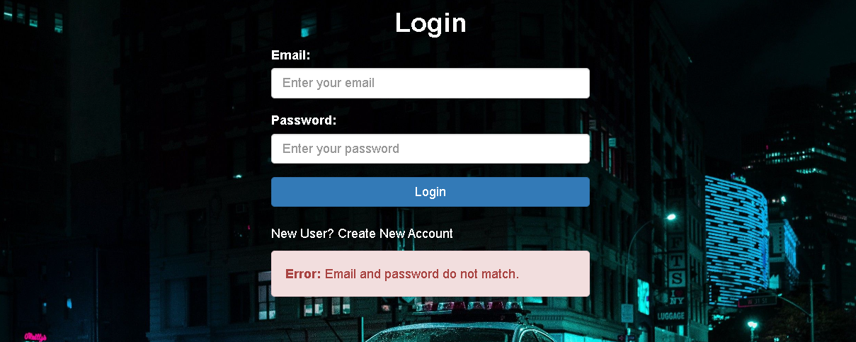

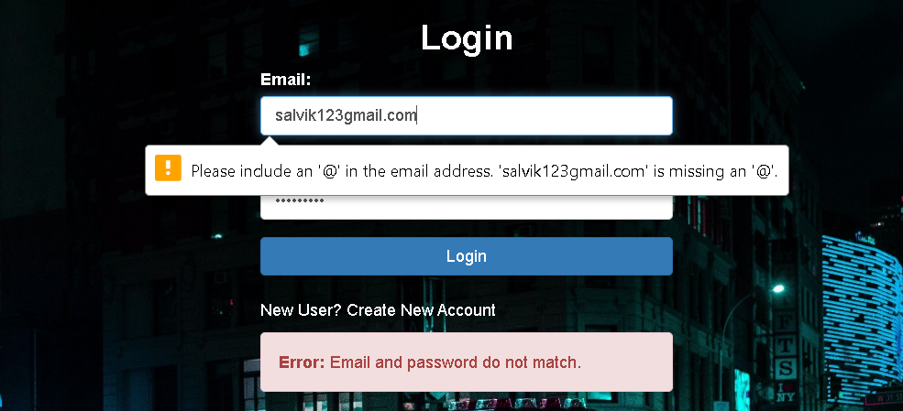

**code for validating email and password during Login:-**package com.ecrh.backend;

import java.io.IOException;

import java.sql.Connection;

import java.sql.DriverManager;

import java.sql.PreparedStatement;

import java.sql.ResultSet;

import javax.servlet.RequestDispatcher;

import javax.servlet.ServletException;

import javax.servlet.annotation.WebServlet;

import javax.servlet.http.HttpServlet;

import javax.servlet.http.HttpServletRequest;

import javax.servlet.http.HttpServletResponse;

import javax.servlet.http.HttpSession;

@WebServlet("/loginServlet")

public class Login extends HttpServlet {

private static final long serialVersionUID = 1L;

public Login() {

super();

}

protected void doPost(HttpServletRequest request, HttpServletResponse response) throws ServletException, IOException {

response.setContentType("text/html");

String myemail = request.getParameter("email");

String mypass = request.getParameter("password");

String errorMessage = null; // Initialize an error message

try {

Class.forName("com.mysql.cj.jdbc.Driver");

Connection con = DriverManager.getConnection("jdbc:mysql://localhost:3306/ecrh", "root", "rony");

PreparedStatement ps = con.prepareStatement("select * from users where email = ? and password = ?");

ps.setString(1, myemail);

ps.setString(2, mypass);

ResultSet rs = ps.executeQuery();

if (rs.next()) {

HttpSession session = request.getSession();

session.setAttribute("session_username", rs.getString("name"));

session.setAttribute("user_email", rs.getString("email")); // Store the user_email in the session

// session.setAttribute("user_role", "user"); // Indicate this is a user session

// Redirect to the after_login page

response.sendRedirect("after_login.jsp");

} else {

// Set an error message

errorMessage = "Email and password do not match.";

}

} catch (Exception e) {

e.printStackTrace();

// Set an error message for exceptions

errorMessage = "An error occurred while processing your request.";

}

// If there is an error message, forward to the login page with the error message

if (errorMessage != null) {

request.setAttribute("errorMessage", errorMessage);

RequestDispatcher rd = request.getRequestDispatcher("/login.jsp");

rd.forward(request, response);

}

}

}

**ADMIN PANEL- DELETE USER VALIDATION:-**

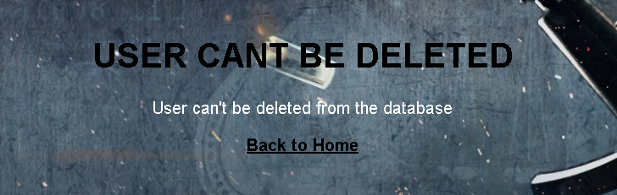

If the registered user has filed an FIR under his email , then unless an until the FIR record is deleted , the admins cant delete the user’s data , since its violates the integrity constraint of primary key.

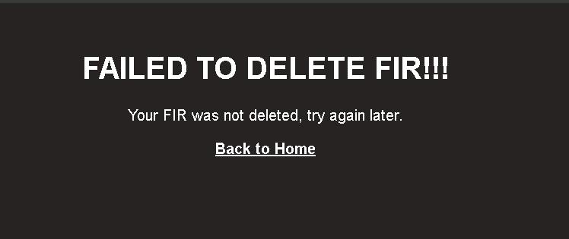

Once the FIR is deleted, and if the admin tries to delete the same entry again, it will raise an exception, since the record is no longer existed.

# FUTURE SCOPE

* + **Performance optimization:** This could involve conducting a thorough analysis of the application's code and database queries to identify areas for optimization.
  + **Integration with other systems:** This could involve integrating the application with other databases, APIs, or third-party software to extend its functionality and improve its usefulness. Like **Google Map API’s**  for accessing nearby police station based on our location, **OTP Authentication** during login process, etc.
  + **Enhancing security:** This could involve implementing security measures such as encryption, access control, and authentication to ensure that user data is protected.
  + **Adding new features:** As the needs of users evolve, there may be a need to add new features to the application. For example, new forms, reports, or dashboards could be added to provide users with additional functionality and insights into their data.
  + **Mobile optimization:** With the increasing use of mobile devices, optimizing the application for mobile devices could be a future development area.
  + **Multi-language support:** This would involve creating translations of the application's user interface and content to make it accessible to users who speak different language
  + **Deploy the web Application on cloud :** We can host our application on cloud thus enabling multiple benefits like - cloud storage , cost effectiveness, easy maintenance , more secure database & data recovery tool and many more. ex- AWS, Azure, GCP.
  + **Improving and enhancing the ADMIN panel :** Add section for category where the police department can categorize complaints based on various categories of crimes, we can include state-wise crime panel where the admins can monitor crime from different states and can perform further analysis like finding out crime-rates from each state, locality etc.

**CONCLUSION**

The development and implementation of the E-CRIME REPORT HUB mark a significant step forward in modernizing the process of filing FIRs and managing crime-related incidents. This project aimed to address the limitations of traditional methods by introducing an online platform accessible to victims worldwide.

Throughout the development process, the focus remained on creating a user-friendly interface and robust functionalities. The system allows users to register, file FIRs, access articles related to different crime categories, and provides a guide for seamless navigation.

The utilization of technologies such as Java EE, JavaScript for client-side validation, and MySQL for database management enabled the creation of a secure and efficient system. JavaScript-based validations ensured data accuracy and enhanced the user experience during registration and FIR filing.

Manual testing played a pivotal role in ensuring the system's reliability and functionality. Test scenarios covered positive and negative testing, validating user inputs against JavaScript-based form validations. Positive testing confirmed the system's response to valid inputs, while negative testing checked its behavior when presented with invalid or unexpected data.

While this project primarily focused on manual testing, there remains room for future enhancements. Potential improvements include incorporating automated testing methodologies to streamline the testing process, ensuring greater test coverage and efficiency.

In conclusion, the E-CRIME REPORT HUB stands as a testament to leveraging technology to simplify and expedite the reporting and management of criminal incidents. With continuous evaluation and potential enhancements, it aims to be a reliable and indispensable tool for both victims and law enforcement agencies in addressing and managing crimes effectively.

# BIBLIOGRAPHY

* + <https://www.w3schools.com/js/js_validation.asp>
  + <https://www.oracle.com/java/technologies/java-ee-glance.html>
  + <https://dev.mysql.com/doc/>
  + <https://getbootstrap.com/docs/5.3/getting-started/introduction/>
  + <https://www.lucidchart.com/pages/>
  + <https://app.diagrams.net/>
  + <https://www.techopedia.com/definition/16213/entity-relationship-diagram-erd>
  + <https://developer.mozilla.org/en-US/docs/Web/JavaScript>
  + <https://docs.oracle.com/javaee/5/tutorial/doc/bnakc.html>
  + <https://docs.oracle.com/javaee/7/tutorial/jsf-facelets005.htm>
  + <https://docs.oracle.com/javaee/7/tutorial/servlets.htm>
  + <https://www.digitalocean.com/community/tutorials/java-servlet-tutorial>
  + <https://www.tutorialspoint.com/servlets/index.htm>